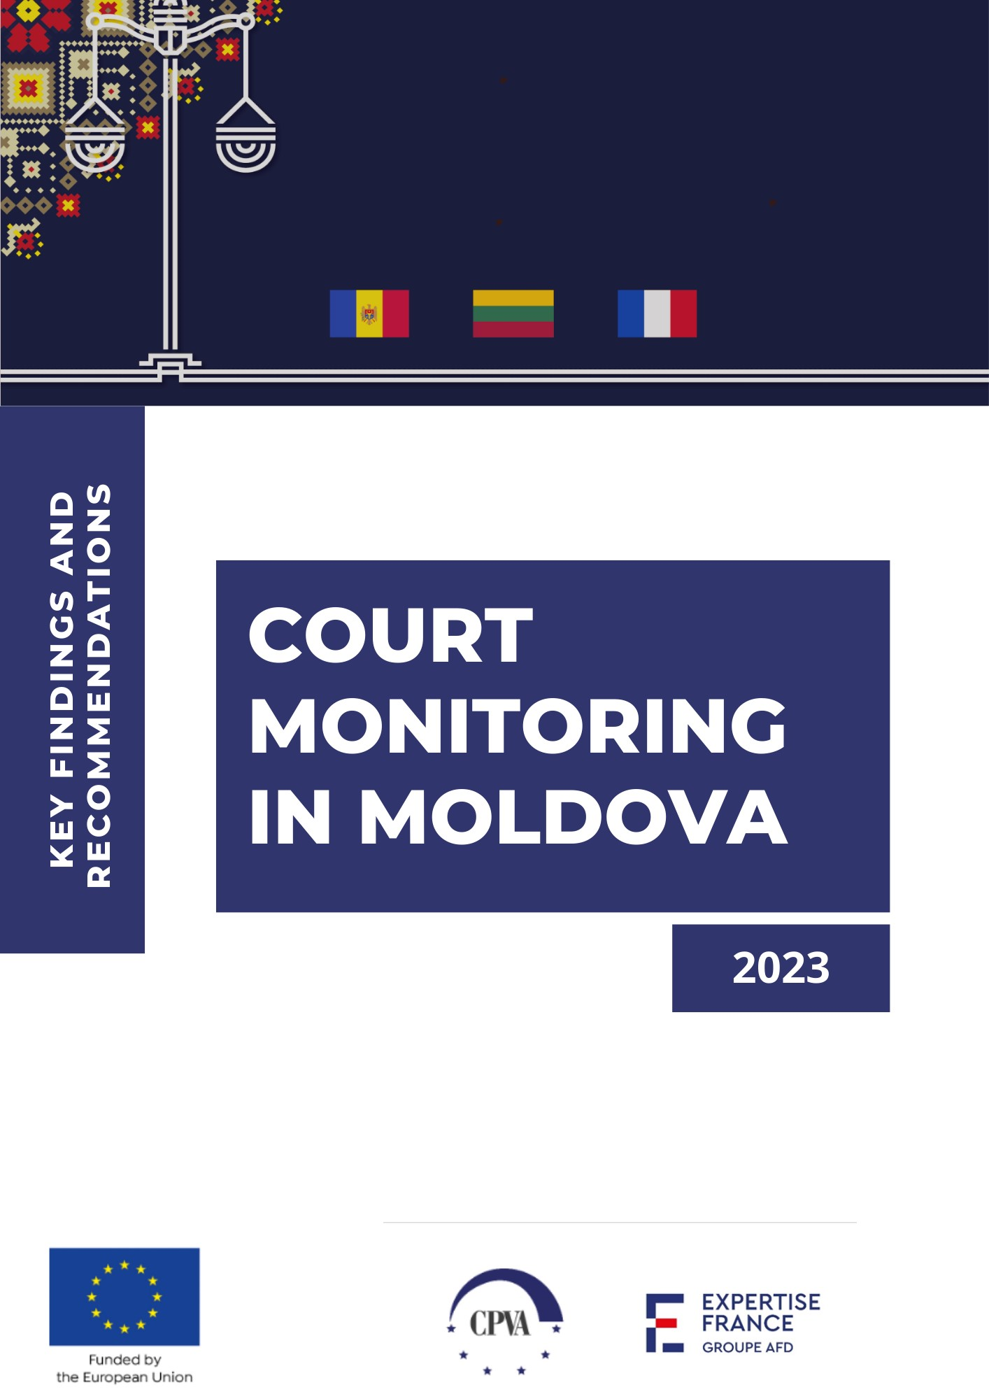
TABLE OF CONTENTS
1. INTRODUCTION 3
2. METHODOLOGY 4
3. ACCESS TO JUSTICE 9
3.1. LEGAL ASSISTANCE 9
3.2. LEGAL AID 10
3.3. LITIGATION COSTS AND THEIR RECOVERY 12
3.4. PROTECTION OF VULNERABLE GROUPS 15
3.5. CONCLUSIONS AND RECOMMENDATIONS 16
4. ADHERENCE TO FAIR TRIAL RIGHTS 18
4.1. FAIR TRIAL RIGHTS IN CIVIL CASES 18
4.2. FAIR TRIAL RIGHTS IN ADMINISTRATIVE CASES 21
4.3. FAIR TRIAL RIGHTS IN CRIMINAL CASES 25
4.4. FAIR TRIAL RIGHTS IN ADMINISTRATIVE OFFENCES CASES 27
4.5. KEY FINDINGS AND RECOMMENDATIONS ON FAIR TRIAL RIGHTS 29
4.6. EFFECTIVENESS OF THE TRIAL PROCESS ORGANIZATION 33
5. EVALUATION OF ACCESS TO JUSTICE IN PRE-SELECTED TYPES OF CASES 37
6. ACCESS TO JUSTICE IN THE HIGH-PROFILE CASES 41
7. PROFESSIONALISM OF LAW-RELATED ACTORS 45
8. CONFIDENCE IN JUDICIAL SYSTEM 53
9. QUALITY OF JUDICIAL DECISIONS 59

1. INTRODUCTION

The First Component of the European Union-funded project, 'Enhance Transparency, Accountability of and Access to the Judiciary System' was conducted in Moldova between 2022 and 2023. The Court Monitoring Report provides a comprehensive overview of the monitoring activities carried out to assess the adherence to fair trial rights in court proceedings and quality of judicial decisions.
The Report collates information on key aspects of judicial activities. It encompasses information regarding access to courts, the conduct of court proceedings, and the issuance of judicial decisions across different types of cases, including civil, criminal, administrative, and administrative offenses cases. Additionally, it delves into specific case categories, each characterized by its unique complexities, such as data protection, domestic violence, environmental protection, legal aid provision, and non-contractual state liability.
The Report offers valuable insights and recommendations drawn from monitoring activities. It highlights both the strengths and weaknesses of the Moldovan judicial system, all in the pursuit of our overarching goal: promoting transparency, accountability, and enhanced access to justice for all.
The analysis of monitoring results draws from multiple sources, including Trial Monitoring, Court Users Surveys, Focus Group Surveys for Private Lawyers, State-Funded Lawyers, Judges, and Judicial Personnel, Expert Interviews, and Monitoring of Judicial Decisions. Covering trials conducted from July 15, 2022, to May 30, 2023, and court decisions issued between 2020 and 2022, this report stands as a comprehensive reference for the latest developments in the Moldovan justice system.

2. METHODOLOGY

The implementation of the First Component of the European Union-funded project 'Enhance Transparency, Accountability, and Access to the Judiciary System' is grounded in a comprehensive methodology consisting of two distinct models: (1) The Trial Monitoring methodology is designed to assess the compliance of procedural rights, as well as the professionalism of law-related actors; (2) The Methodology for Monitoring Court Decisions focuses on key aspects affecting the quality of reasoning in court decisions, such as legal comprehensibility, clarity, consistency, accuracy, and procedural correctness.
The monitoring covers a range of cases, including civil, criminal, administrative, and administrative offenses cases, along with specific categories like as data protection, domestic violence, environmental protection, legal aid provision, and non-contractual state liability. This comprehensive approach aims to identify bottlenecks in the justice system and offer recommendations for improving accessibility, quality, and trust in the judicial system.

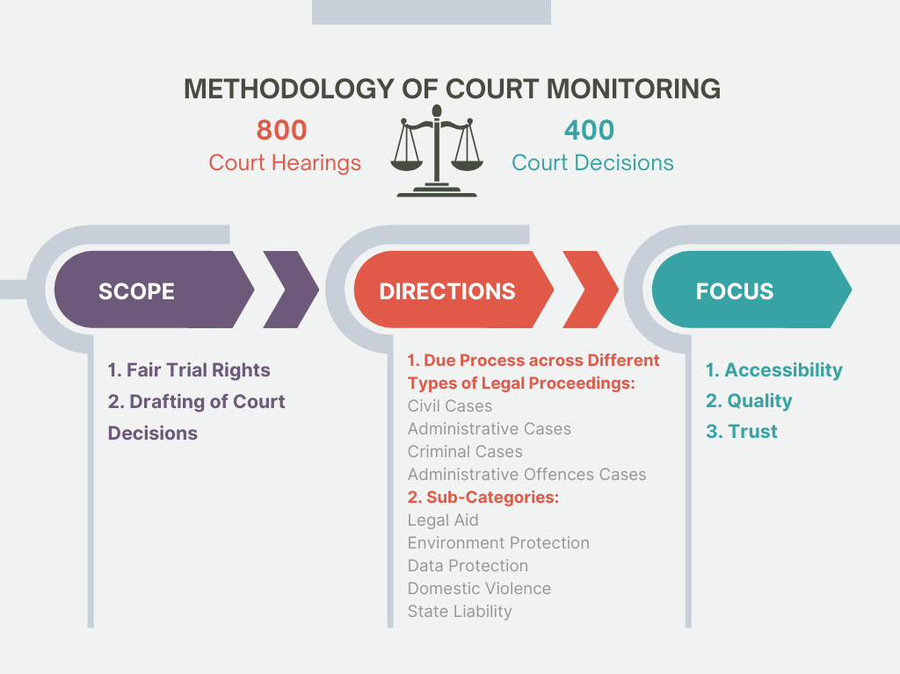
A notable proportion of the monitoring activities centres around cases in the Chisinau courts, including the Chisinau Court of Appeal, as well as regional courts.
Specifically, 75% of the monitoring activities were conducted within the premises of the Chisinau court, encompassing the Chisinau Court of Appeal, with the remaining 25% carried out in regional courts at the first level and regional appeal courts. The assessment of the quality of court decisions also includes cassation proceedings (10%).
In terms of case selection for court hearing observation and the evaluation of court decisions, cases were chosen randomly. With the exception of high-profile cases, the case-selection methodology is rooted in an ad hoc monitoring concept, which primarily focuses on observing single court hearings rather than an entire set of trials within a case or the complete judicial process of those cases. This approach ensures that a diverse caseload is covered and reduces reliance on case-specific external circumstances.

2.1. Scale and Duration of Monitoring

The Trial Monitoring activities took place 15 July 2022–30 May 2023, observing 800 court proceedings across various case categories.
The general sample of monitored court hearings included 800 court hearings, of which:
Court hearings in civil cases – 281 (36%)
Court hearings in administrative cases – 112 (14%)
Court hearings in criminal cases – 281 (34%)
Court hearings in administrative offences cases – 126 (16%)
Including the following subtypes of cases:
Court hearings in cases in which legal aid is provided – 76 (10%)
Court hearings in cases relating to environmental matters – 19 (2%)
Court hearings in cases concerning data protection – 43 (5%)
Court hearings in cases concerning domestic violence – 52 (7%)
Court hearings in cases on non-contractual liability of state – 52 (7%)
Court hearings in set of trials concerning high-profile cases – 70 (9%)
25% (198) of the total monitored hearings took place in the appellate courts.

Monitoring of Court Decisions took place simultaneously. 400 Court decisions issued between 2020 and 2022 were analysed. Most of the monitored judgments were handed down by national courts during 2020 (39% or 156 judgments), 33% (130) in 2021 and 28% (114) in 2022.
The general sample for monitoring the quality of court decisions included, in total, 400 court decisions. The distribution of decisions was as follows:
Civil cases – 130 (33%)
Criminal cases – 95 (24%)
Administrative cases – 90 (22%)
Administrative offences cases – 85 (21%)
At the same time, the monitoring sample also included the decisions given in certain sub-types of cases (134 in total), as follows:
Decisions in cases in which legal aid is provided – 16 (4%)
Decisions relating to environmental matters – 26 (6%)
Decisions concerning data protection – 32 (8%)
Decisions in domestic violence cases – 35 (9%)
Decisions on non-contractual liability of state – 25 (6%)
72% (287) were issued by the first instance, 15% (60) on appeal and 13% (53) on cassation.

The focus of monitoring extends to court users with experience of a court case, legal professionals, state-appointed lawyers, judges, and judicial personnel. Their feedback on court services, procedural rights, and the quality of judicial decisions provides valuable insights into the justice system.
Trial Monitoring also presented data regarding the Court Users Surveys. There was a total of 155 respondents in this survey. The distribution of case types in which respondents were involved revealed that civil cases accounted for the largest portion (37%). Administrative cases followed closely at 19%, while criminal cases and administrative offenses cases represented 29% and 15% respectively.
Focus Group Surveys were conducted between 22 September 2022 – 31 October 2022. The Surveys of Lawyers were completed by 78 respondents within the group of private lawyers and the Surveys for Lawyers Providing State-guaranteed Legal Aid (referred as Survey for State-Funded Lawyers) – by 88 respondents within the group of state-appointed lawyers. The Survey for Judges and Judicial Staff was distributed to judges and judicial staff with support of the Agency for Court Administration and filled by them between 22 September 2022 – 31 October 2022. 133 judges and judicial personnel participated in the Survey. 69% of respondents work at the court of first instance, and 31% – at the court of appeal.
Expert Interviews. Twenty-one interview was conducted in the framework of the monitoring in October 2022–March 2023. Experts were invited to participate in the interviews having regard to their recognized competences and experience developed in different areas of specialization.

2.2. Key Aspects Monitored in the Proceedings and Judicial Drafting

The monitoring process covers various aspects of access to justice, due process, and the delivery of judgments, including the role of legal professionals, and the quality of reasoning in court decisions.
ACCESS TO JUSTICE
- Effective access to a competent, independent and impartial court
- Right to information about case at trial
- Right to a public trial
- Right to a legal counsel
- Right to equal access for vulnerable groups
- NGO's access to court
COURT HEARING
- Right to a competent, independent and impartial court
- Comprehensibility of procedural rights and duties
- Right to be heard
- The role of the judge
- Professionalism and performance issues related to legal practitioners
- Specific rights of vulnerable groups
- Presumption of innocence, where applicable
- etc.
DELIVERY OF THE JUDGMENT
- Right to a public and reasoned judgment
- Accessibility to the case-law
OTHER ISSUES TO BE MONITORED
- Perception of the justice system by court users
- Effectiveness of court administration
- The payment of costs and other legal expenses related to the proceedings
- Specific issues regarding high-profile cases

2.3. Monitoring Methods

Multiple methods were employed, such as court hearing observation, court users surveys, focus group surveys, analysis of court decisions, and qualitative expert interviews with lawyers and judges. These methods provide a comprehensive understanding of the justice system, allowing for the collection of both quantitative and qualitative data.
The data for the analysis was prepared by the Centre for the Analysis and Prevention of Corruption (CAPC).

2.4. Principles of Monitoring Activities

Monitors operated in accordance with principles of objectivity, confidentiality, quality, and non-intervention. Monitors were also required to have extensive legal experience and qualifications. These principles aimed to ensure impartiality and provide reliable and comparable data throughout the monitoring process.

3. ACCESS TO JUSTICE

The monitoring results provided an overview of the state of access to justice in Moldova, encompassing both the general situation and specific aspects of legal services, litigation costs and related issues.

3.1. LEGAL ASSISTANCE

The right to a lawyer is a fundamental pillar of each just legal system, ensuring that individuals have access to proper legal representation and a fair trial. A lawyer plays a vital role in protecting an individual's rights, offering legal advice, defending before the court, and navigating the complexities of the law. In Moldova, the right to be represented by a lawyer is fully recognised in the legal acts and is established in practice. However, certain shortcomings and particularities of practical implementation of this right were noted in the monitoring activities.
Legal Representation in Judicial Proceedings
- In most of the monitored cases the parties were assisted by privately hired lawyers. In most monitored cases, the monitors considered that the lawyers were mostly well prepared.
Civil Cases: Private lawyers were predominantly used by litigants (88% of monitored court hearings). Monitors observed little difference in the treatment of state-funded and private lawyers, with rare instances of one side being better prepared. Overall, no significant issues with legal assistance were noted.
Administrative Cases: Lawyers represented parties in the majority of administrative cases (70%). The monitors identified only a few cases where lawyers were not thoroughly familiar with the case materials.
Administrative Offenses Cases: In most instances, defendants chose their lawyers (68%), while 33% used state-guaranteed legal aid. In a few cases (2%), lawyers were not well-acquainted with the case materials.
Criminal Cases: State-guaranteed legal aid was more common in criminal cases (64%). Private lawyers represented defendants in 36% of cases, with minimal differences in their treatment. Lawyers were generally well-prepared, and instances of unfamiliarity with case materials were rare.
- Regarding legal services quality in Moldova, significant improvements in the quality of legal services in the country were noted. These improvements were attributed to several factors: higher entrance to the Bar requirements; better and continuing training for lawyers; the influx of young lawyers entering the legal profession; competition created by young lawyers, particularly in urban areas.
- The Trial Monitoring results revealed quite a positive court users opinion about the legal assistance available in the country:

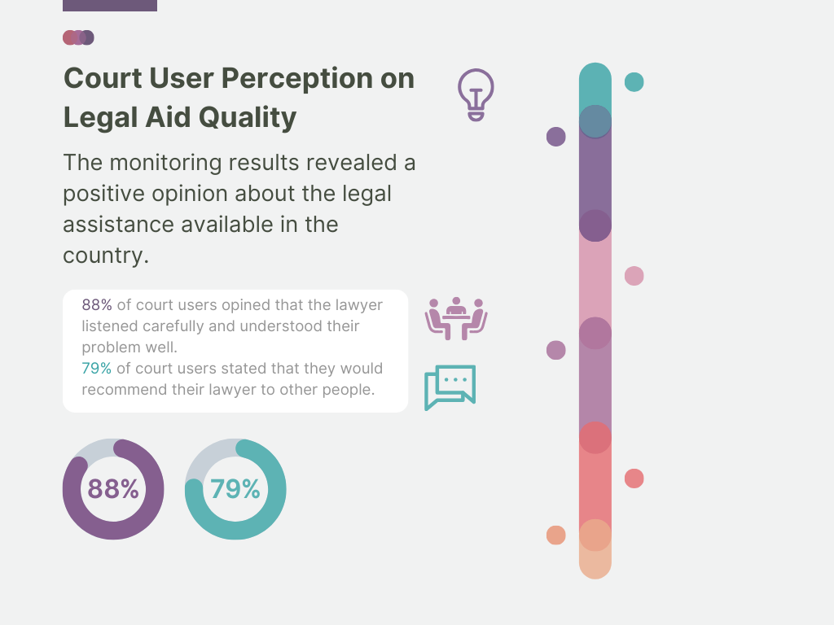

3.2. LEGAL AID

In general, the quality of legal aid may face several constraints that hinder its effectiveness in providing comprehensive legal support to those in need. One significant constraint is the limited funding and resources allocated from the state budget to legal aid provision. Moreover, legal aid lawyers may face heavy caseloads, leaving them with little time to devote to each case, potentially affecting the quality of representation. Lack of motivation and inadequate training may also impede the quality of legal aid services. Similar concerns were noted during monitoring in Moldova.
Several critical factors affect the quality of legal aid services, and it is evident that these factors are interconnected:
High Workload and Limited Time to Prepare for the Case
- Ensuring a reasonable workload for legal aid lawyers is crucial for maintaining the quality of services. Excessive caseloads can hinder the ability of lawyers to provide high-quality assistance. To address this, proper funding should be allocated to hire an adequate number of qualified lawyers, and clear guidelines should be established to determine reasonable caseloads based on factors like case complexity. The lack of different approach towards a workload calculation with regard to the complexity of the case and limited time to prepare a case were the most stated reasons for constraints of quality (49% and 39% of respondents within the group of state-funded lawyers, respectively, selected the above-mentioned reasons).
Lack of Mutual Trust
- Building mutual trust between legal aid clients and their lawyers is essential for effective representation. Clients who trust their lawyers are more likely to cooperate, share essential information, and positively evaluate the legal aid system. Communication, openness, and transparency are key to developing this trust. In 36% of state-funded lawyers expressed concern that in the case of a state-appointed representation, the mutual trust between a lawyer and a client may be weak. This also seems to be connected with the fact that 27% of respondents indicated that there is a difference in attitude where the state-funded lawyers are mostly expected to take up a passive role.
Lack of Fair Remuneration
- Lower remuneration of legal aid lawyers poses a significant hurdle to the quality of legal aid services. Low pay can deter experienced lawyers from taking legal aid cases and lower pay may lead legal aid lawyers to dedicate less time to legal aid clients, as a result, this can compromise the quality of legal aid. In the Focus Group Surveys for State-Funded Lawyers, the question of financial motivation turned out to be important but not decisive when one considers the most significant constraints of the efficiency of the legal aid system. Financial motivation was indicated by 30% of respondents as “very important” and by 26% – as “important”. During the Expert Interviews, however, the vast majority of experts focused on the factor related to the insufficient pay of state-guaranteed legal aid lawyers.
Specialization of Legal Aid Lawyers
- While specialization of legal aid lawyers can lead to deeper expertise, it may be challenging to implement in smaller countries or towns with limited resources. While it is valuable, the lack of specialization may not have a significant negative impact on the quality of legal aid services. In the Focus Group Surveys for State-Funded Lawyers conducted in Moldova, legal aid lawyers’ specialization was selected as a “very important” factor in ensuring quality legal aid by 25% of respondents.

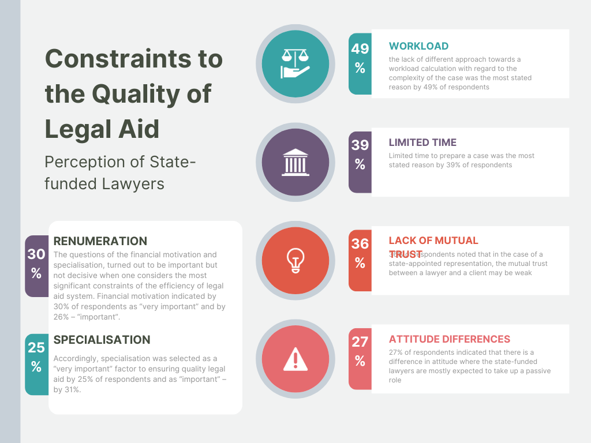

3.3. LITIGATION COSTS AND THEIR RECOVERY

Litigation costs and their recovery are important elements when analysing access to justice as they can significantly impact an individual's ability to pursue their legal rights in courts. The monitoring results reveal the need to improve the litigation cost recovery mechanism in Moldova. The lack of clarity and inconsistent practices affect both parties involved in legal proceedings and the lawyers representing them, causing uncertainty and potential disputes.
Legal Costs and Access to Justice
- In Moldova, the perception of legal costs for access to justice varies among surveyed lawyers and court users. Most lawyers felt that the costs were average, and very few considered them to be high. However, court users generally perceived the litigation costs as high, with lawyer expenses and travel expenses being significant concerns. Furthermore, court fees and the costs associated with evidence collection and travel were also rated as substantial barriers to accessing the justice system. Addressing these cost-related challenges is essential to ensure equitable access to the legal system.
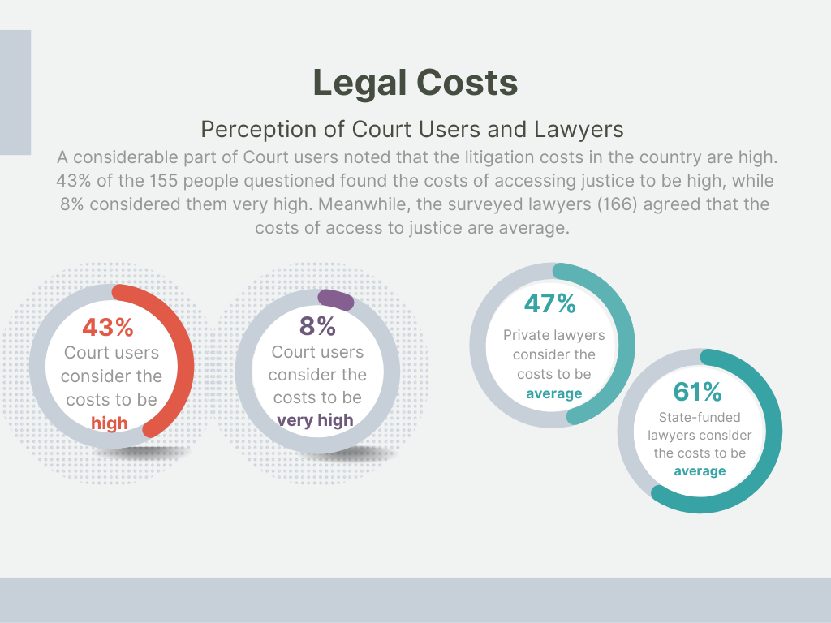
Reimbursement of Legal Costs
- Most parties (79%) did not request reimbursement of representation costs. In civil cases, 43% applied for reimbursement, while in criminal cases, only 5% did so. The rates for administrative were 20% and for administrative offenses cases – mere 2%.
- In first-instance courts, the reimbursement of legal representation costs was granted in 54% of the cases where parties requested it. In appellate courts, reimbursement was granted in 75% of relevant cases. In cassation courts, reimbursement was granted in 60% of relevant cases. Courts did not calculate the exact duration of legal assistance provided in most cases. They typically specified the amount to be granted to lawyers.
- The legal framework requires the compensation of real and necessary expenses, but the application of this rule is inconsistent. The analysis suggests that the reimbursement of legal representation costs often relied on the discretion of judges. Factors influencing the reimbursement amount include the complexity of the case, complexity of legal services, special legal knowledge, previous involvement of the same lawyer, amount of the dispute, continuity and nature of legal services, novelty of legal issues, conduct of the parties, lawyers' working time, etc.

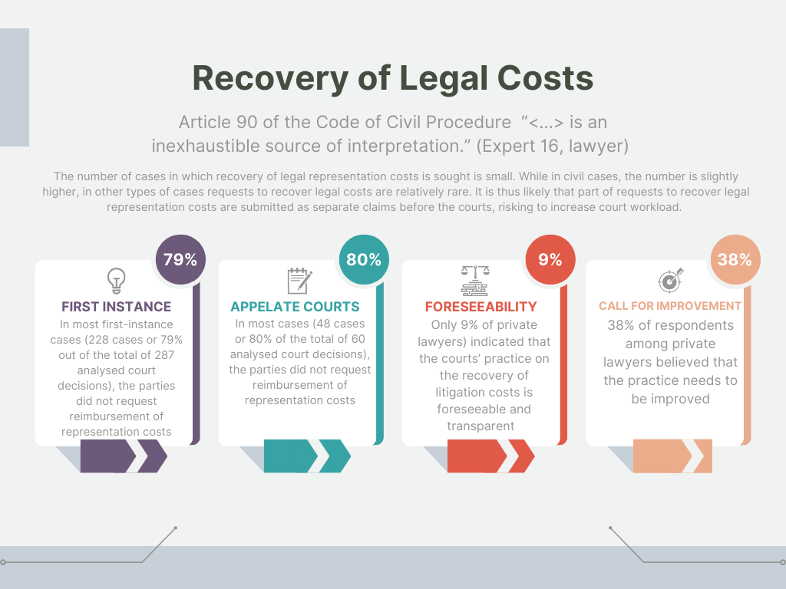

3.4. PROTECTION OF VULNERABLE GROUPS

Vulnerable groups before the courts refer to segments of the population that are more susceptible to experiencing disadvantages, discrimination, and unequal treatment within the legal system. Vulnerable groups, such as minors, minorities, people with disabilities, immigrants, underprivileged individuals, and victims of domestic violence, often encounter systemic barriers that hinder their ability to navigate the legal system effectively.
A survey of lawyers revealed mixed perceptions regarding the adequacy of the legal system's adaptation to accommodate vulnerable people. While some state-appointed lawyers believed the system was moderately adapted, private lawyers expressed more reservations, with a substantial portion considering the system adapted to a small extent.
Key Findings from the Trial Monitoring echoed these perceptions:
Physical Accessibility Challenges
- The monitoring results highlighted the challenges of physical accessibility for individuals with disabilities in courtrooms. Many court facilities lacked the necessary infrastructure, such as ramps, elevators, and accessible entrances, making it difficult for people with mobility impairments to access courtrooms.
Limited Participation of Vulnerable Groups
- The monitoring revealed that vulnerable groups were notably underrepresented in court proceedings. Only a minor part of court hearings (around 2–3%) included the participation of vulnerable persons. It is highly likely that, in most cases, counting the number of persons from vulnerable groups in the court hearings, the perception of vulnerable groups included only persons with physical (moving) disabilities.
- When vulnerable individuals did participate in court hearings, various measures were taken to assist them. These included adjusting procedural rules to accommodate their needs, providing support personnel like psychologists and social workers, and simplifying legal language.
- The monitoring results noted that in Moldova, there is a lack of established quality criteria for legal aid provided to vulnerable groups. Additionally, there is no clear specialization for lawyers in this area.

3.5. CONCLUSIONS AND RECOMMENDATIONS

Legal Assistance
Recommendation 1: Implement a System of Continuous Training for Lawyers. To ensure the quality of legal assistance and uphold the standards of the legal profession, a comprehensive system of continuous training for lawyers should be implemented. It should encompass various aspects, such as legal updates, communication skills with clients, handling vulnerable groups, etc. Currently, the Law on the Bar of the Republic Moldova stipulates that lawyers must dedicate a minimum of 16 hours annually to continuous learning, however, the existing control mechanisms for verifying compliance with this obligation are limited in their effectiveness. Therefore, establishment of more rigorous and effective control measures should be considered.
Quality of Legal Aid
Recommendation 1: Balance Legal Aid Workloads and Remuneration. It is necessary to allocate sufficient funding to the legal aid system so it can hire an adequate number of qualified lawyers. As a connected measure, it would be advisable to establish clear guidelines for determining a reasonable caseload for legal aid lawyers. These guidelines should consider factors such as case complexity, the level of the court, and the type of the case. The data on the number of cases being handled by legal aid lawyers could be held in digital form. The legal aid administrator should then conduct regular assessments to identify any excessive workloads.
Recommendation 2: Strengthen the Trust. To strengthen mutual trust, the legal aid client should be granted an opportunity to choose a lawyer. Regarding the scenario where the legal aid client fails to exercise their right to select a specific lawyer, the legal aid administrator should take a decision selecting the lawyer, based on the principle of equal treatment, caseload of legal aid lawyers, client’s needs (the lawyer's particular expertise, language proficiency, etc.).
Recommendation 3: Enhance the Quality and Independence of State-Funded Legal Aid Programs. To ensure that state-funded legal aid programs maintain high-quality standards and accountability, the legal aid administrator could implement regular evaluations and feedback mechanisms. When improving the legal aid quality monitoring mechanisms, it is advisable to seek consensus and compromise with the lawyers’ professional organisations (the Bar, the Union of Lawyers). It is most appropriate that the more robust legal quality review is implemented by the community of lawyers themselves. Alternatively, the community should be included with equal decision-making rights in the process of ensuring the legal aid quality.
Recommendation 4: Advance Data Collection for Legal Aid Provision. Data collection for the situations where legal aid was provided should be further developed. This development would enable an analysis of the specific contexts in which legal aid is sought and provided, offering insights into the demographics, types of cases, geographic distribution, and outcomes.
Recommendation 5: Review Legal Aid Eligibility. Various measures can be employed to enhance the legal aid accessibility for vulnerable groups and prevent instances of abuse. The Law on Legal Aid can include a provision stating that legal aid will not be granted if the cost of providing assistance is disproportionately high compared to the claim amount. Another effective tool is to assess the viability of legal representation. Moreover, legal regulations may limit legal aid in situations where the applicant is claiming non-pecuniary damage to their honour. Situations where a person applies for legal aid in multiple cases should be addressed.
Recovery of Litigation Costs
Recommendation 1: Establish Clear and Transparent Principles for Litigation Cost Recovery. To ensure a fair and transparent process, there is a need for clearer and more well-defined principles guiding the recovery of litigation costs in Moldova. While judges should have some margin of appreciation to consider the specifics of each case, establishing and adhering to consistent and understandable principles would enhance predictability and fairness. In this regard, guidelines adopted by the Supreme Court could be particularly useful.
Recommendation 2: Promote the Recovery of Legal Representation Costs in Main Proceedings. The number of cases in which recovery of legal representation costs is sought is small. It is thus likely that part of such requests is submitted as separate claims before the courts. Such an approach might result in a significant burden on the already strained judicial infrastructure, increasing caseloads and delays, and placing added pressure on court resources.
Protection of Vulnerable Groups
Recommendation 1: Implement Necessary Modifications to Enhance Access for Individuals with Disabilities. In this regard, on the state level, it is advisable to implement necessary architectural modifications. This might involve installing ramps, elevators, accessible entrances, and adequate signage to guide individuals with disabilities.
Recommendation 2: Provide Specialized Training for Judges to Address the Needs of Vulnerable Groups in Court Proceedings. Such training should be designed to equip judges with the necessary legal knowledge to uphold the rights of vulnerable individuals, adapt communication to their needs, prevent bias, and make well-informed decisions.
Recommendation 3: Enhance Awareness about Access to Legal Aid. Vulnerable individuals may be unaware of the legal aid services available to them. Therefore, tailored efforts should be made to inform these groups about their rights, and how to access legal assistance.

4. ADHERENCE TO FAIR TRIAL RIGHTS

This section delves into the critical aspects of ensuring fair trial rights within the judicial system. In the following subsections, we explore key facets of these rights, shedding light on accessibility, transparency, and procedural fairness across civil, administrative, criminal cases, and administrative offenses cases. This analysis extends to both the conduct of oral proceedings and the overall professionalism exhibited by the courts.

4.1. FAIR TRIAL RIGHTS IN CIVIL CASES

The analysis encompasses 281 court hearings, with 79% held in courts of first instance and 21% in appeal courts.
Accessibility and Transparency in Civil Cases
- Court information was generally clear, with 99% providing details like hearing times, involved parties, and presiding judges. However, the clarity of technical information shows room for improvement. Regarding first instance courts, 43% had clear signposting, 45% had reservations about data clarity.
- In 46% of cases, public access was unrestricted, while 41% required attendees to state their purpose, and 11% demanded identification. First instance courts tended to be more cautious, with 24% requiring attendees to explain their presence, whereas appellate courts mostly (97%) allowed open access.
- Regarding equal access, the analysis revealed that interactions between litigants and judges, preliminary dialogues, and courtroom ethics were well-maintained in the majority of cases. Both first instance and appellate courts demonstrated high standards of professional conduct, with only six hearings (2%) showing potential deviations.
- Only one case in the first instance courts involved an NGO defending public interests, while two cases had NGO representatives in an observational role. There were no instances of NGOs submitting 'amicus curiae' briefs.
Conduct of Oral Proceedings
- A significant majority of court hearings (79%) adhered to the scheduled trial calendar. Explanations for delays were limited, with only 12% providing justifications and 18% receiving apologies. Differences were observed between first instance and appellate courts, with appellate courts displaying a higher percentage of delayed cases.
- Civil case hearings were often brief, with 36% lasting up to 15 minutes and 34% extending up to 30 minutes.
- Approximately 25% of monitored cases were postponed. Lengthy breaks due to organizational aspects (e.g., there is no shared access to lawyer's schedules; multiple short hearings are set at the same day) and the need for enhanced preparedness and cooperation among involved parties contributed to the lack of efficiency of proceedings.
- In half of the cases, the court explained procedural rights and obligations. The explanation of rights was typically done in a formal manner.
- A significant majority of 241 observed hearings (86%) featured the presiding judge articulating the right to challenge the court's composition. However, in 2 instances (1%) where such challenges were raised, they were subsequently dismissed.
- The level of judicial activism varied and depended on the personal qualities and disposition of the judge. Only a limited number of cases considered factors such as age, capacity, and physical or mental condition of court attendees. The imposition of fines as punitive measures for procedural infractions was a rare occurrence (3 cases).
- In most cases (96%), parties were provided the opportunity to present their essential arguments. Nevertheless, court users expressed mixed levels of satisfaction with the time allocated for presenting arguments. Among the respondents, a modest 3 (5%) expressed being "very satisfied" with the provided duration. In comparison, 16 (28%) were "satisfied". The largest segment, 20 (35%) noted "average satisfaction".
- The practice of deliberating in chambers varied, with approximately half of the cases involving deliberations in a secluded room.
- Most judgments were pronounced publicly and on the indicated date. Mostly the operative part was announced (76%). Explanations of decision reasons and the distribution of litigation costs were infrequent (up to two cases). 57% of cases had decisions available on the court's website within 30 days.
Overall Professionalism of the Court
- Judges consistently demonstrated a high level of professionalism (98% of cases). Courts were characterized by a solemn atmosphere, with virtually no distractions such as mobile phone use during sessions. Inappropriate remarks or conduct were rare, with 98% of cases maintaining a professional and respectful environment. Importantly, no breaches of judicial impartiality were observed. There were no instances of premature disclosures on dispute outcome or decisions influenced by gender biases.
- Court users indicated a generally favourable view of judges' attitude and courtesy. Approximately 50% of participants expressed positive assessments, with 5% being "very satisfied" and 46% "satisfied." A significant portion (30%) maintained a neutral stance, characterizing their experience as "average satisfaction.". Respondents perceived the attitude and courtesy of court staff as satisfactory in approximately 44% of cases. Around 39% expressed their satisfaction with the professionalism of court staff.

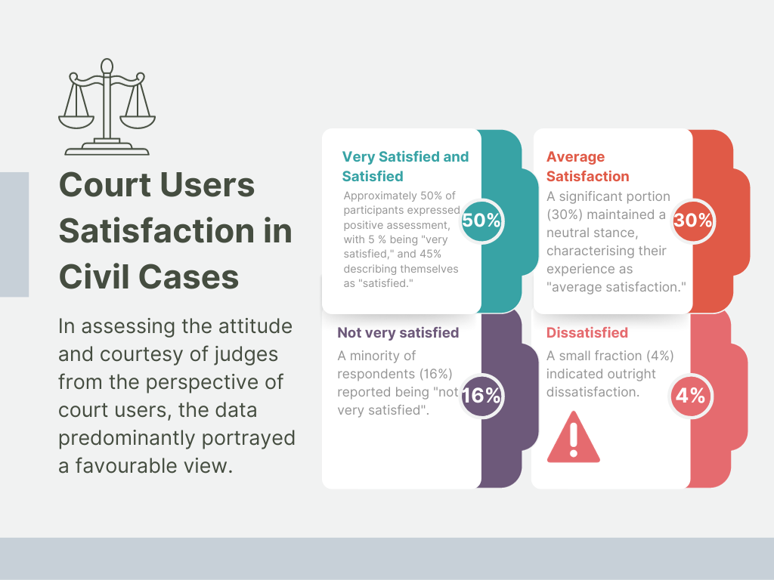

4.2. FAIR TRIAL RIGHTS IN ADMINISTRATIVE CASES

A total of 112 court hearings in administrative cases were monitored. The majority of these hearings (76%) occurred in first instance courts.
In 2018, the Republic of Moldova enacted a new Administrative Code. This monumental development in Moldovan law shifted the monitoring focus towards the practical implementation of innovative provisions in administrative justice. The results of the monitoring confirm that there is no uniform practice among the courts in implementing the innovations outlined in the Administrative Code. Despite that, legal professionals consider the Administrative Code to be very progressive: “The Administrative Code at first seemed very strange to everyone. However, it has proven to be a godsend for us and comes to the aid of citizens, primarily. It compels authorities to prioritize discipline because the Code outlines clear responsibilities and duties." (Expert 2, judge)
Accessibility and Transparency in Administrative Cases
- Court schedules and premises provided information for 99% of hearings. Practical information for litigants was predominantly clear, and the public's access to courtrooms was largely unrestricted.
- In most cases, the public was unconditionally accepted in the courtroom (54% of cases). However, in 33% of court hearings, the public was accepted after explaining the reasons for attending the court hearing, and in 12%, after requesting an identity document.
- Regarding equal access, in the majority of cases, litigants entered and left the courtroom simultaneously, and there were no alarming off-the-record discussions regarding the litigation between litigants and the judge noted.
- Regarding the access of NGOs to the court, procedures were initiated on behalf of the community or the groups represented in 2 cases. In another case, NGO representatives acted as non-legal advocates in support of vulnerable groups or people with disabilities.
Conduct of Oral Proceedings
- A significant majority of court hearings (70%) adhered to the scheduled trial calendar. Explanations for delays were limited (2 cases).
- Approximately 45% of cases witnessed the court appropriately explaining procedural rights and obligations in accordance with Article 56 of the Code of Civil Procedure. In approximately 60% of cases, the parties were not informed about their procedural rights related to changing the subject-matter of the case and other as set out in Article 60 of the Code of Civil Procedure. Inquiring if parties understood their procedural rights and obligations was practiced in 53% of cases.
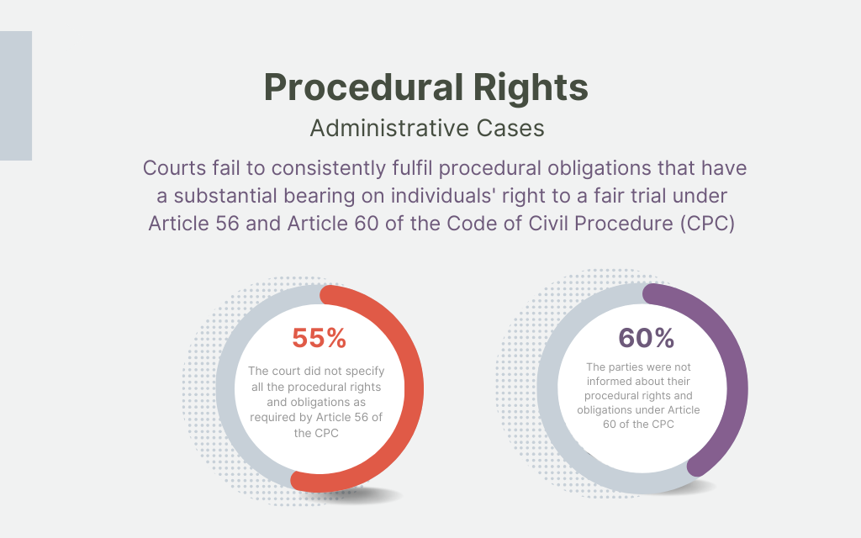

- Parties' right to challenge the court's composition was consistently explained in 90% of monitored hearings, resulting in only one filed challenge that was subsequently dismissed.
- Regarding the role of the court in administrative proceedings, the court upheld their procedural duty to explain all their actions in 67% of court hearings. The court's failure to inform about the comprehensive ex officio examination of case circumstances was observed in 61% of applicable cases. The court's ex officio examination of all case circumstances demonstrated variable levels of activity. Approximately 70% of applicable cases saw the court actively examining all aspects. Furthermore, nearly 29% of court hearings were postponed for various reasons. In some instances (9 cases), new evidence presented beyond deadlines was admitted. In some cases, the court rejected requests for new evidence, with varying degrees of legal justification. In addition to this, it should be noted that the first instance courts demonstrated a more consistent procedural clarity.
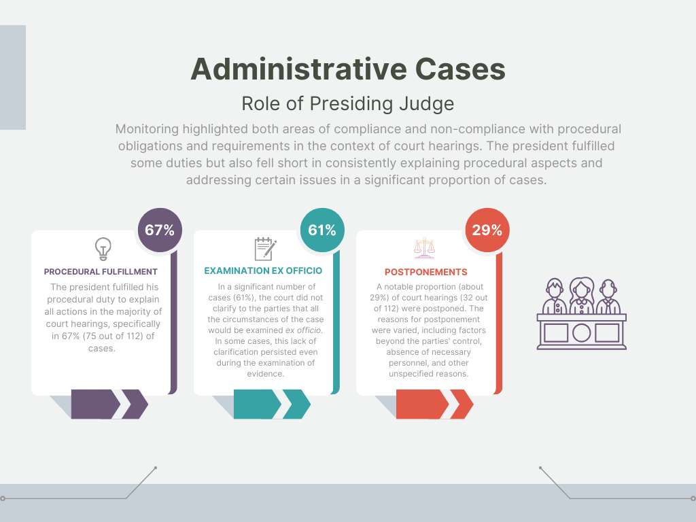

- Rare and inconsistent efforts aimed at rectifying errors and delivering clarifications as set out in Article 219(2) of the Administrative Code were observed

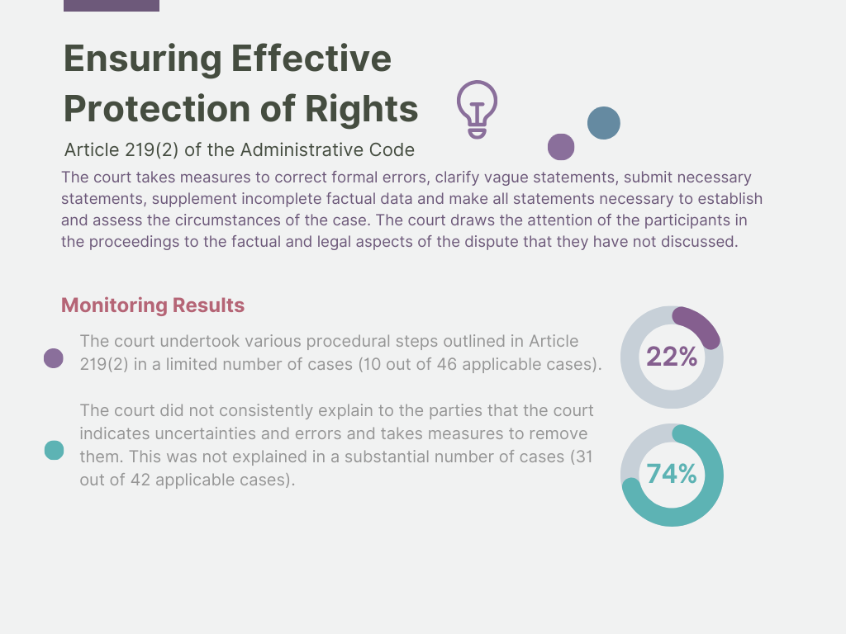
- In the majority of cases (99%), parties were given the opportunity to present their arguments fully. However, there were a few cases (2 hearings) where limitations on the duration of speeches were observed.
- The court engaged in legal discussions (Article 219(4) of Administrative Code) in a relatively small proportion of cases (14% of applicable cases). These discussions were primarily conducted verbally. The court did not provide written instructions regarding the legal situation of the cases.
- Regarding judicial deliberations, the court employed both private deliberations in the deliberation room (60% of cases) and in-court deliberations. Deliberation duration varied, with some decisions reached relatively quickly. The majority of deliberations (15 cases) were relatively short, lasting less than 15 minutes.
- Decisions were usually pronounced publicly on the indicated date. The court usually informed about the appeal process, but the main reasons for decisions were not consistently explained during the announcement. After the judgment was pronounced in all cases, the judge did not explain the reasons for the decision taken. As regards explanation of legal costs, in only one case, the distribution of costs was explained by the judge. The availability of decisions on the court's website was relatively prompt in most cases.
Overall Professionalism of the Court
- The majority of court hearings (98–99%) demonstrated a high level of professionalism, with judges' commitment ethical standards. They maintained their focus, refrained from distracting behaviours, and avoided making tactless or unethical statements towards participants. Judges also stayed focused on core case issues and refrained from disclosing their positions prematurely, ensuring impartiality. The court exhibited a commitment to gender neutrality.
- The Court Users Surveys further indicated positive perceptions of court staff's attitude and courtesy. A significant proportion of respondents, 50% expressed average satisfaction with the demeanour of court personnel.

4.3. FAIR TRIAL RIGHTS IN CRIMINAL CASES

In a study of 281 criminal court hearings, 183 hearings (68%) were monitored in the courts of first instance, and the remaining 88 (32%) in the court of appeals.
Accessibility and Transparency in Criminal Cases
- The vast majority (96%) displayed details in the court's schedule and premises. The clarity of court information was generally good, although there were occasional issues with outdated schedules and courtroom mismatches.
- A significant percentage of cases (59%) allowed unrestricted public access, with more openness observed in appellate courts. However, in some cases, attendees were required to explain their presence.
- As regards equal access, a total of 88% cases saw no discussions between court users and judges prior to the hearings. Post-hearing interactions were similarly limited, with 92% exhibiting no such dialogues.
- NGOs had minimal involvement in criminal cases, with only a few instances of participation, primarily in advisory roles.
Conduct of Oral Proceedings
- Court punctuality varied, with some delays observed, particularly in first instance courts. Specifically, 73% adhered to their predetermined schedules. However, a noteworthy proportion (27%) deviated from the schedule. Only a minority of cases, specifically 5 hearings, did the judges take the initiative to acknowledge and apologize for the delays.
- The right to legal representation was generally upheld, with courts postponing hearings in cases of absent defence attorneys. Out of the total of 281 monitored court hearings, 14 cases (5%) were postponed when the defence attorney did not appear.
- Explanation of procedural rights varied, with room for improvement in ensuring clarity. Regarding the cases in first instance courts, 84 cases (59%) demonstrated a clear and comprehensive presentation of participants' rights. In contrast, out of the 88 cases in appellate courts, clear explanation of rights was provided in 31 cases (48%).
- The first instance courts explained the right to challenge court composition clearly in 91% of cases. Similarly, in appellate courts, 94% of cases provided clear explanations.
- The role of the court in criminal cases was adaptable, ranging from active to passive, with a majority of cases falling into a mixed category where the court's role depended on the hearing stage. First instance courts tended to have a higher percentage of active roles compared to appellate courts.
- The presentation of charges and the defendant's comprehension of these charges showed some variability between first instance and appellate courts, highlighting the need for consistency in procedures. In first instance courts, a detailed presentation of charges was observed in 45 cases (66%) out of 68 applicable cases, while a shortened version was presented in 23 cases (34%). Conversely, in the appellate courts, out of 45 cases, a comprehensive presentation of charges occurred in only 11 cases (24%), with a summarized presentation being prevalent in 34 cases (76%).
- In a substantial proportion of instances, defendants were indeed asked about their preferred timing for testifying. Specifically, in 62 cases (approximately 63%), judges proactively inquired about the defendant's preferred testimony schedule.
- The right to an objective and comprehensive evaluation of evidence was generally maintained, with additional evidence and requests for additional evidence being relatively infrequent. In 89% of cases, additional evidence was not presented by the parties.
- The right to be presumed innocent and the right not to be compelled to testify or confess guilt were generally upheld, with few instances of undue pressures (2 cases). However, there was room for improvement in explaining the defendant's right not to answer questions without adverse consequences. In the majority of cases, about 89% (31 out of 35 applicable cases), this explanation was not provided to the defendant.
- Judicial deliberations in criminal cases were generally prompt, with most cases concluding within 15 minutes, accounting for approximately 61% of cases.
- The delivery and publication of judicial decisions called for improvement in providing comprehensive explanations for decisions and clarifying the distribution of litigation costs. A significant proportion of cases (79%), featured the operative part of the judgement being publicly pronounced. A substantial majority (90%) of cases were pronounced publicly on the indicated date. In the vast majority of cases (97%), there was a notable absence of explanations for the decision or the distribution of legal costs. It was found that about 53% of cases ensured that the judgment was available in less than 30 days.
Overall Professionalism of the Court
- Judges displayed professionalism and impartiality throughout the trial process. While minor distractions were observed, including cell phone usage in 6 cases in first instance courts and 4 cases in appellate courts, these instances were relatively infrequent. A positive trend was observed in both court levels, with a strong focus on the merits of the cases. In first instance courts, 99% of cases remained firmly centred on the subject matter of the case, with only one instance of unrelated questioning. Appellate courts maintained a consistent focus on the cases without any reported deviations. Gender sensitivity was consistently upheld, with no instances of inappropriate language or behaviour observed.
- In terms of participants' satisfaction with the attitude and courtesy of judges during the hearings, the data reflects a generally positive inclination. Of those surveyed, 33% expressed satisfaction with the judges' demeanour, while 48% indicated an average level of satisfaction, suggesting a neutral perception. The attitude and courtesy of court staff also garnered nuanced responses. A majority (56%) expressed average satisfaction with the courtesy of court staff, with 33% indicating satisfaction. It is noteworthy that in 21% of the hearings, court staff proactively provided unsolicited assistance.

4.4. FAIR TRIAL RIGHTS IN ADMINISTRATIVE OFFENCES CASES

A total of 126 court hearings, with 82% occurring at first instance courts and the remaining 18% at appeal courts were monitored in administrative offences cases.
Accessibility and Transparency in Administrative Offenses Cases
- Court's schedule was available in 97% of cases, with 99% providing clear details. Challenges related to real-time room allocation were noted, mainly in appellate courts.
- Approximately 48% of cases required attendees to provide a rationale for their presence, while 36% adopted unconditional access.
- The majority of hearings adhered to formal and impartial judicial proceedings. In 70% of cases, the parties left the courtroom at the same time. A substantial 79% demonstrated no preliminary exchanges between court users and the judges. This trend was also observed post-session. Interactions between opposing parties generally remained neutral.
- NGOs played a limited role, with only one case featuring their distinct participation in the first instance courts.
Conduct of Oral Proceedings
- A significant majority of court proceedings (73%) adhered strictly to the established schedule. A significant concern arises from the evident lack of communication surrounding the observed delays. Among all hearings that experienced deviations from the schedule, only a single case provided reasons for such delays.
- In cases of the absence of a defence attorney, the court chose to postpone proceedings in 8 cases, accounting for approximately 6% of the total. It is noteworthy that appellate courts proceeded with the hearing in the absence of a defence attorney in 4 cases, while the courts of first instance did so in 11 cases.
- In a majority of hearings, specifically 69%, the rights of participants were explained clearly. In 75% of cases. an additional step was taken to confirm participants' understanding of these rights.
- The right to challenge the composition of the court was explained in 78%. It is worth noting that, despite frequent articulation, no challenges were made.
- In 42% of the hearings, the court assumed an active role. When analysing the role of courts in both the first instance and appellate instance, distinct patterns emerged. In the courts of first instance, the court played an active role in 47% of cases. The appellate instance court was actively involved in a mere one case.
- The presentation of charges varied. Courts of first instance presented charges comprehensively more often, in 35 cases (47%), whereas in appellate courts, shortened presentations were presented in all monitored instances.
- The defendant's preference for testifying was often considered. In approximately 55% of cases, the defendant was asked about their preference regarding when they wanted to testify. It is noteworthy, that at the appellate courts, the defendant was asked when they preferred to testify in a single case.
- Evaluation of evidence relied mainly on existing materials. In the majority of cases, (approximately 80%), no additional evidence was presented by the parties.
- Judicial deliberations often (63% of cases) took 15 minutes or less. In approximately 46% of cases, the judges chose not to adjourn to chambers, possibly influenced by the urgency or specific characteristics of the cases.
- Most judgments were pronounced publicly, mostly the operative part (88%), but detailed reasons were rarely provided. In only one case the judge did offer an explanation for the decision. Similarly, when evaluating the explanation of reimbursed litigation costs, the communication of these costs by the judge was minimal. Information on appeal procedures was generally communicated in 74% of cases. The availability of judgments on the court's website varied, with most accessible within 30 days (61% of cases).
Overall professionalism of the Court
- In a substantial majority of cases (approximately 95%), judges remained consistently present in the courtroom, maintaining impartiality and focus on the cases. Instances of cell phone usage by judges were rare, observed in only one case.
- High standards of professional conduct were evident in approximately 99% of cases, with judges refraining from inappropriate comments. Judges consistently demonstrated relevance and impartiality, with approximately 97% avoiding unrelated questions.
- 30% of participants expressed satisfaction with the attitude and courtesy displayed by judges, while a minority (2 respondents) expressed dissatisfaction. Regarding court staff's courtesy, 57% of respondents expressed an average level of satisfaction.

4.5. KEY FINDINGS AND RECOMMENDATIONS ON FAIR TRIAL RIGHTS

Comprehensive monitoring of civil, administrative, criminal, and administrative offenses cases has revealed common findings across all categories. The Moldovan judiciary exhibits strengths in timeliness, judge's professionalism, and impartiality but faces challenges related to explanation of procedural rights, communication of judicial decisions, clarity of information, NGO involvement and other issues. The following list outlines the issues that need to be addressed:
1. Punctuality and Communication Challenges. While there is a commitment to follow scheduled timetables, issues related to communication regarding delays require improvement. 26% of hearings started with a delay, with no explanations provided for the majority of these delays.
2. Challenges in Court Hearings Planning and Time Allocation. The most prevalent durations for all case hearings were either brief, lasting up to 15 minutes, accounting for 305 hearings (38%), or slightly longer, up to 30 minutes, which applied to 251 hearings (31%).
3. Lack of Explanation of Procedural Rights and Duties. The monitoring data unveils a mixed overview of the explanation of procedural rights and obligations. While most judges explain the right to challenge the court's composition, substantial deficiencies arise in adequately informing parties about their rights and duties. Such explanations were lacking in 50% of civil cases, 55% of administrative cases, 53% of criminal cases, and 31% of administrative offenses cases.
4. Inconsistent Practices in the Course and Conduct of Court Hearings. Inconsistencies in defendant testimony timing, presentation of additional evidence, and judicial activity were observed. Addressing these issues requires training for legal professionals and the implementation of standardized procedures to uphold judicial impartiality and fairness.
5. Diversified Deliberation Approach. The analysis highlights a diversified approach to deliberations, with 54% of observed sessions opting for secluded deliberations post-hearing, while 46% choose immediate in-session judicial deliberations in civil cases. In criminal cases, this ratio was 48%:52%, in administrative cases 60%:40%, and in administrative offenses cases 54%:46%. This distinction warrants further investigation to understand its impact on judgment quality.
6. Lack of Explanation of Judicial Decisions. A significant shortfall is observed in the explanation of judicial decisions, with inadequate explanation of judgments and litigation cost allocations in 98% of cases (287 out of 293 cases). This underscores the need for greater transparency and clarity in decision rationale and cost distribution.
7. Inconsistent Online Publication of Judicial Decisions. There is a clear inclination towards online publication, as 57 % of decisions in civil cases, 64% in administrative cases, 53% in criminal cases, and 61% in administrative offences cases were available within 30 days. However, a significant percentage of decisions are published with delays or not published at all.
8. Limited NGO Involvement. The absence of NGOs in 98% of monitored hearings is a significant representation gap within the legal system. Increasing the integration of NGOs in legal proceedings is crucial for enhancing public representation and observational efforts.

These challenges can be addressed through the following suggestions. It should be noted that implementing these tailored recommendations with due diligence and careful consideration to Moldova's unique socio-legal context is imperative for addressing the identified inefficiencies.

Recommendation 1: Enhance Availability and Consistency of Courtroom Information. It is recommended that the judicial system works towards ensuring the availability and consistency of courtroom information, especially within the appellate courts. Efforts should be made to bridge the gap between scheduled and real-time room allocations to avoid any confusion among attendees. Proactive assistance from court staff can be expanded to maintain a smooth flow of information.
Recommendation 2: Improve Comprehensiveness Regarding Explanation of Procedural Rights and Duties. To address the variability observed in explaining participants’ rights and court proceedings, Moldova should develop guidelines aimed at enhancing the clarity and comprehensiveness of legal proceedings. These guidelines should also establish uniformity in the presentation of charges and ensure defendants' understanding of their charges.
Recommendation 3: Ensure Judicial Neutrality and Professionalism. Continuous training and awareness programs aimed at fostering impartiality play a vital role in upholding unbiased legal proceedings and maintaining the highest standards of judicial professionalism. To ensure judicial neutrality and professionalism, comprehensive steps should be taken, including regular training programs for judges that emphasize impartiality, close monitoring of ethics committees, the development of clear guidelines for judges' conduct, transparent case assignment procedures, and public awareness campaigns to encourage citizens to report concerns about judicial conduct.
Recommendations 4: Enhance Judicial Transparency by Adopting Rules for Explanation of Judicial Decisions upon Delivery. Moldova should implement precise rules mandating explanations of reasons for the adopted judgments and detailing the allocation of litigation costs. This will foster increased transparency and justifiability in judicial decisions.
Recommendation 5: Strengthen Online Publication Mechanisms. Moldova should prioritize the consistent implementation of online publication rules and maintain a regularly updated, user-friendly database. This effort aims to ensure that every judgment is promptly and reliably available online, addressing the existing deficit in online publications and fostering public trust.
Recommendation 6: Enhance Integration of NGOs in Legal Proceedings. Given the significant representation gap, fostering a more inclusive legal culture through enhanced and more clear procedural roles of NGOs is crucial. Clear procedural roles for NGOs, such as third-party involvement, 'amicus curiae' contributions, and non-legal advocacy, should be established.

In the evolving landscape of Moldova's legal system, the effective application of the new Administrative Code is crucial in safeguarding individuals' rights in disputes with public administration entities. Through a comprehensive analysis, we have identified several additional recommendations to enhance the efficiency and fairness of administrative justice. These proposals aim to address key aspects of administrative cases, including procedural stability, appellate procedures, explanation of judicial decisions, and the role of judges in administrative proceedings.

Recommendation 1: Maintain the Legal Stability of the Administrative Code aimed at Public Entities. The new Administrative Code has gained momentum and is considered an effective mechanism by the judicial system for safeguarding individuals' rights in disputes with public administration entities. Therefore, we propose refraining from making fundamental amendments to the Administrative Code that would alter the procedures outlined within it concerning the execution of public administration actions.
Recommendation 2: Consider amending the procedural rules to introduce a written appellate procedure. This amendment suggests that administrative cases in the appellate procedure should, as a rule, be examined through written proceedings, without the participation of the parties in the dispute. Oral examination of administrative cases could be considered when the court deems it necessary, either on its own initiative or upon the request of the involved parties.
Recommendation 3: Consider Establishing a General Rule That Requires the Explanation of Primary and Essential Reasons When Delivering Judicial Decisions. The nature of administrative disputes also suggests that the Administrative Code should mandate that courts state the primary and essential reasons for their judgments when delivering decisions.
Recommendation 4: Harmonize Active Judicial Role with Adversarial Principle. Our proposals focus on shaping judges' attitudes to ensure effective judicial control of public administration entities' activities while safeguarding the rights and interests of participants in the administrative process. In essence, an active judge in this context is one who takes a proactive role in seeking a fair and just resolution to administrative disputes, rather than merely adhering to formal procedures. The goal is to uphold the principles of justice and fairness in the administrative court's decisions without showing partiality toward any specific party. This approach is crucial for environmental, energy, and construction law cases, where specialized legal knowledge is required and numerous secondary legal regulations are involved. Specialized, long-term practice in administrative justice will not only develop consistent legal interpretations but also manage judges' workloads. Such continuity aids the establishment of uniform judicial practices, essential for legal certainty in a system without court precedent recognition, thereby upholding the rule of law.

4.6. EFFECTIVENESS OF THE TRIAL PROCESS ORGANIZATION
“Discussions on organizing work and scheduling hearings have been neglected for a while. Previously, they tried to talk about this, but since the amount of work is large, everyone is glad that the work is going as it is.” - Expert 17 (judge)
The assessment of trial process organization effectiveness focuses on organizational arrangements and workload management solutions in the judicial system.
Organizational Arrangements of Court Services
- Court users expressed varying levels of satisfaction with organizational aspects. The majority, 41%, indicated they were "satisfied" with waiting conditions and courtroom furnishing. A substantial 42% expressed "average satisfaction.". Meanwhile, professional lawyers, particularly state-appointed lawyers, raised concerns about organizational aspects, such as signposting, parking, and communication. Regarding satisfaction with the organizational aspects, around one-third of respondents in lawyers group indicated that they are very satisfied or satisfied with them.
Setting Hearing Times and Managing Delays
- Deviations from scheduled timings were observed in a significant number of cases (26%), with very minimal communication and apologies from judges.
- Monitoring identified coordination challenges, interruptions, and excessive scheduling as key factors impacting the perception of judicial services. Many hearings were disrupted by lengthy breaks, and the duration of hearings was often insufficient. Statistical data illustrates that, for example, the most common duration for civil case hearings was either up to 15 minutes (36% of cases) or up to 30 minutes (34% of cases).
Work-Load Management Solutions
“A good judge assistant is worth their weight in gold“- Expert 16 (lawyer)
- High workload in the justice system is a long-standing concern, with variability in how judges manage their caseloads. Limited specialized training for judges in managing hearings and working time contributed to inefficiencies. Judges largely rely on informal knowledge sharing to improve organizational skills.
- Regarding personnel management, the importance of capable assistants and court clerks was stressed but challenges related to turnover and low salaries noted. The issue of small salaries for judicial personnel was a consistent concern, leading to a high turnover of staff and significant impacts on the organization and quality of work. The primary motivation for judicial personnel is the prospect of advancing their careers within the judicial system. Salaries for secretaries and assistants were highlighted as being extremely low in comparison to their workload and stress levels. The lack of timely training for judicial personnel contributed to challenges in their initial responsibilities.
Procedural Framework Impacting Work Management Solutions
"There's no culture of mediation. Even if we provide mediation advice, there are no takers. It's not taken seriously, even though mediation could be an opportunity to reduce the workload." - Expert 13 (lawyer)
- Possible legal culture reasons may be contributing to the lack of interest in mediation in Moldova. Nonetheless, promoting the use of alternative dispute resolution methods, like mediation, could help reduce the workload. Mandatory mediation should be generally provided for specific case types, such as family and labour cases.
- The application of simplified procedures in civil cases is not popular in Moldova, with judges expressing concerns about potential abuse.
- There is a consensus among legal professionals, that enhancing enforcement instruments, particularly by granting an executive character to certain documents such as utility bills, could be a practical solution to reduce the burden on the courts.
- Expert Interviews have underscored the necessity to reassess court fees to dissuade individuals from pursuing trivial or matters of personal principle through the judicial system. They have identified substantial numbers of repetitive cases, notably involving debt-related issues in civil cases and certain matters in administrative offenses cases.

The majority of the problems identified in the analysis of trial monitoring results across all types of cases arise from the high workload of the courts. However, the way in which judges plan and organize the trial process not only extends the duration of the proceedings but also hinders the efficient use of available resources. Additionally, the organization of court proceedings is complex, and the postponement of cases is often due to the lack of efficient methods in coordinating the calendars of trial participants. Addressing these organizational and procedural challenges, improving training of judges, and implementing modern communication systems can contribute to a more efficient and effective judicial system in Moldova.

Recommendation 1: Addressing the challenges associated with the high workload in Moldova's justice system will require an improved application of available procedural tools within the judicial process. To this end, the following measures could be considered:
- Promote Alternative Dispute Resolution (ADR): Increase the emphasis on mediation and other ADR methods to reduce the burden on the courts. Mandatory mediation before applying to the court in certain groups of cases, especially in areas like family and labour law, should be considered. Educational programs to shift the legal culture and promote mediation are highly recommended. International collaboration and exchange programs can also be beneficial in integrating effective mediation practices observed in other countries.
- Review Court Fees: The court fees should be reconsidered to discourage frivolous lawsuits. Implementing a minimum claim amount for certain types of cases might help alleviate the court's caseload. Fees for alternative methods of resolving disputes, such as mediation, should be incentivized to promote their usage.
- Promote Simplified Procedures: Raise awareness about simplified procedures among lawyers and judges through seminars and workshops. Highlight the advantages of using such procedures for eligible cases. Strengthen the legal framework to mitigate the risks observed in the "Laundromat" incident. This may involve establishing clear criteria for documents that can be accepted in this procedure and incorporating safeguard mechanisms to prevent fraud.
- Establish Streamlined Debt Collection Process: Consider amending the legislation to grant specific documents, such as utility bills, an executive character, allowing them to proceed directly to bailiffs without requiring court intervention unless contested. Provide training and capacity-building for bailiffs to handle these direct enforcement cases, ensuring they possess the necessary tools to execute these orders quickly and fairly.
- Consider Adoption of Written Procedures for Appellate Courts: Given the excessive workload of judges, adopting a predominantly written procedure could ensure a more systematic and comprehensive review of cases. A maximum duration for written procedures, such as six months, should be established to prevent undue delays and ensure timely justice.
Recommendation 2: Addressing the challenges associated with high workload may require a combination of improved organizational practices and specialized training:
- Provide Judges with Formal Training and Clear Guidelines for Allocating Appropriate Time to Different Types of Hearings. To achieve this, initial meetings may be kept relatively shorter, while hearings focused on discussing the merits of a case should be allocated longer durations to ensure a thorough and comprehensive review.
- Establish a Mentorship Program within the Judicial System. Judges with exemplary procedural practices can act as mentors to less experienced judges, offering guidance and promoting the dissemination of good practices.
- Establish a Centralized and Shared Online Access System for Lawyers' Schedules. Such a system would streamline communication and scheduling among legal professionals, fostering greater efficiency within the judicial process and ultimately improving the quality of proceedings.
Recommendation 3: Regarding Organizational Arrangements, a Feedback and Quality Assurance Mechanism should be established, potentially through the introduction of an ISO-based Quality Management System.
- Implement a Quality Management System where Litigants can Provide Feedback on the punctuality, accessibility, and organization of hearings. This will assist the court administration in identifying areas for improvement.
- Enhance Court Communication Protocols. Whenever there are delays or changes in court proceedings, clear reasons must be provided to all stakeholders to ensure transparency.
Recommendation 4: Address the Need for Improved Salaries and Working Conditions to Retain Talented Personnel within Judicial System. Better remuneration, reduced staff turnover, and enhanced training for judicial personnel are proposed measures to address the systemic challenges and workload issues within the Moldovan justice system.

5. EVALUATION OF ACCESS TO JUSTICE IN PRE-SELECTED TYPES OF CASES

To enable a targeted assessment of specific issues pertaining to access and quality of justice services, the monitoring on pre-selected types of cases in comparison to broader perspective in civil, administrative and criminal cases, was carried out. This approach was rooted in societal and partner concerns and aimed to uncover systemic issues. The selected case types included those related to legal aid provision, environmental matters, data protection, domestic violence, and non-contractual state liability. The comprehensive assessment of sub-types of cases revealed common challenges such as judgment quality, postponements, and trial inefficiencies across all categories. However, unique concerns surfaced in each case type, emphasizing the need for ongoing monitoring and attention to address these specific issues.
Cases Involving Provision of Legal Aid
- Despite the significant advancements made by Moldova's state-guaranteed legal aid system in enhancing access to justice, there remains an ongoing necessity to confront challenges, refine procedures, and secure impartial and high-quality legal representation for all individuals.
- The monitoring results in 76 cases reveal instances where legal aid lawyers displayed limited familiarity with case materials or insufficient preparedness. There were concerns raised regarding the passive role adopted by legal aid lawyers within the system.
- The shortcomings observed in judgments, including the absence of reasons for rejecting certain evidence, assessment of arguments from the unsuccessful party, and references to case law without addressing doubts about the compatibility of relevant laws with higher laws, could also be linked to the quality of legal representation.
- Professionals highlighted variations in the quality of legal assistance offered by the state, indicating that certain legal professionals might not meet the expected standards for the level of representation.
Environmental Cases
- The most significant problem associated with environmental cases is the lack of environmental cases. The relatively low number of monitored environmental cases (19) suggests a potential lack of attention and legal action towards addressing environmental concerns.
- The ambiguity surrounding regulations pertaining to the procedural roles and rights of NGOs in Moldova's legal system poses significant challenges in environmental cases. This ambiguity relates to vague conditions such as "in accordance with the law," which hinder the effective implementation of laws related to NGO representation rights. As a result, meaningful involvement of NGOs in legal processes, particularly in cases of public interest, is impeded due to the lack of specificity in regulations.
Data Protection Cases
- The analysis of data protection cases (43) underscores the significance of this novel legal sphere. Significant variability in the duration of court hearings, with 73% lasting 15 minutes or less, raises concerns about the thoroughness of proceedings. A relatively high rate of case postponements (40%) in administrative data protection cases, compared to the average (29%), leads to delays and potential inefficiencies. Similarly, to general findings, inconsistent explanations of procedural rights and obligations, affects litigants' understanding of their legal standing. It is also essential to address issues related to the clarity and consistency of court judgments and the direct application of legal principles. Given the evolving nature of data protection law, Moldova's legal system should continuously strive for greater precision and transparency to effectively navigate this innovative legal landscape and safeguard individuals' data rights.
Domestic Violence Cases
“Appointed lawyers come to us more often, especially when we have a restraining order, and perhaps due to limited time, they are screened within 24 hours, lawyers are not very prepared. Within a few hours, they must attend a court hearing, and this can be the reason why they are not prepared”- Expert 20 (judge)
- In monitored domestic violence cases (52), a critical examination of issues related to legal representation, the duration of hearings, explanations of participants' rights, judgment quality, and the involvement of non-governmental organizations (NGOs) has underscored the difficulties faced by state-funded lawyers, particularly concerning case preparation within tight time constraints, and lack of active role of judges. Additionally, comments have revealed a concerning issue related to the accessibility of legal aid for victims, despite their statutory entitlement to such support.
Cases Concerning Non-Contractual State Liability
- The monitoring analysis of court hearings involving cases of non-contractual liability of the state (52) has provided insights into both strengths and weaknesses within this legal context. These strengths include a lower rate of court hearing postponements, a more extensive utilization of relevant case law and international human rights treaties, frequent applications for legal representation cost reimbursement. However, these advantages coexist with several notable drawbacks, such as limited overall NGO access to court hearings, slightly lower adherence to trial calendars, variances in the quality of written judgments, insufficient explanations for rejecting evidence, a lower percentage of judgments written in clear language, absence of direct party participation.

The comprehensive assessment of sub-types of cases indicates that there are no substantial disparities when compared to the overall data for all case types. Challenges related to judgment quality, frequent postponements and other trial inefficiencies, including adherence to the trial calendar, unclear practices regarding the reimbursement of legal costs, inconsistent hearing durations and inadequate explanation of participants' rights, are prevalent across all case types, while with varying degrees of ineffectiveness. Nonetheless, specific issues highlighted in each case type, such as the absence of environmental cases, concerns about the accessibility of the legal aid system in cases of domestic violence, inadequate legal representation and limited NGO involvement in most monitored sub-types of cases, lack of a practice of informing parties about the court's active role in determining certain circumstances (ex officio) in cases referring to non-contractual liability of state, underscore the necessity for continuous monitoring and assessment of these case categories, with particular attention to these specific concerns.
The following Recommendations aim to address those issues and foster positive developments:
Cases Involving Provision of Legal Aid:
- Enhance quality in legal assistance through comprehensive training
- Implement standardized quality assurance measures for legal aid service.
- Address inadequate reimbursement policies impacting the motivation and dedication levels of legal aid lawyers.
- Streamline caseloads to optimize the allocation of resources.
- Reconsider the accessibility criteria for the legal aid system.
Environmental Cases:
- Refine legal norms governing NGO participation.
- Define the role of NGOs in legal proceedings.
- Provide clear guidelines for NGO participation.
Data Protection Cases:
- Address the issue of overly short duration of court hearings and develop case complexity assessment.
- Mitigate frequent postponements.
- Enhance explanation of procedural rights.
- Improve the quality of judgments through guidelines and specialized training.
Domestic Violence Cases:
- Reconsider the duration of hearings for domestic violence cases allowing sufficient opportunity for parties to present their cases.
- Enhance explanation of procedural rights.
- Improve the quality of judgments with specialized guidelines.
- Address the challenges of case preparation within limited timeframes
- Raise awareness about legal representation and NGO engagement to inform victims Non-Contractual State Liability Cases:
- Strengthen adherence to the trial calendar.
- Improve the quality of judgments through standardized guidelines and training.
- Enhance transparency and communication.
- Address reimbursement of legal costs.
- Enhance NGO participation and community engagement.

6. ACCESS TO JUSTICE IN THE HIGH-PROFILE CASES
So-called high-profile cases can be seen as "stress-tests" exposing the key strengths and weaknesses of a criminal justice system.
High-profile cases typically refer to legal cases that have gained significant attention and media coverage due to their notable or influential nature. The high-profile nature of these cases often influences public perceptions of the judicial system. In Moldova, three high-profile cases – Ilan Shor, Igor Dodon, and Alexandr Stoianoglo – continue to present significant challenges to the functioning of the justice system, as observed in 70 court hearings.
It is noteworthy that, for the most part, these processes have adhered to the fundamental rules and principles of justice. However, it's important to acknowledge that this state of affairs may be partly attributed to the presence of monitors. As demonstrated earlier, the presence of monitors effectively encourages judges and the involved parties to uphold established standards of conduct.
- Public access was generally permitted without conditions (70%). Some instances included delays and confusion in access due to errors in court information. Instances of deviations from the principle of court hearing publicity were observed, especially in the Shor case. Monitors reported cases of individuals attending court hearings to show support for defendants, including politicians, which led to disruptions.
- All participants received professional legal assistance. In Shor case at the Chisinau Court of Appeal, a prosecutor requested the appointment of a court-appointed lawyer due to unjustified postponements by contracted lawyers. Notably, high-profile cases differ from other monitored categories as many defendants were represented by multiple lawyers.
- Overall, judges maintained solemnity during hearings. No instances of moral or other pressures on defendants were observed. Defendants were informed of their right to remain silent in only one first-instance case. Adverse inferences were not drawn from the defendant's silence, and judges did not pressure defendants to plead guilty. However, in 29 out of 70 monitored hearings, prosecutors were found to lack impartiality, with some reports of unprofessional behaviour and insults towards lawyers.
- A significant number of court hearings (30 out of 36) in the three prioritized cases (Șor, Dodon, Stoianoglo) were postponed or interrupted. Lawyers frequently requested postponements for various reasons, including illness, participation in other hearings, and the need for additional time to study case materials. Prosecutors sought to expedite the trial process and requested judicial fines on lawyers causing delays.

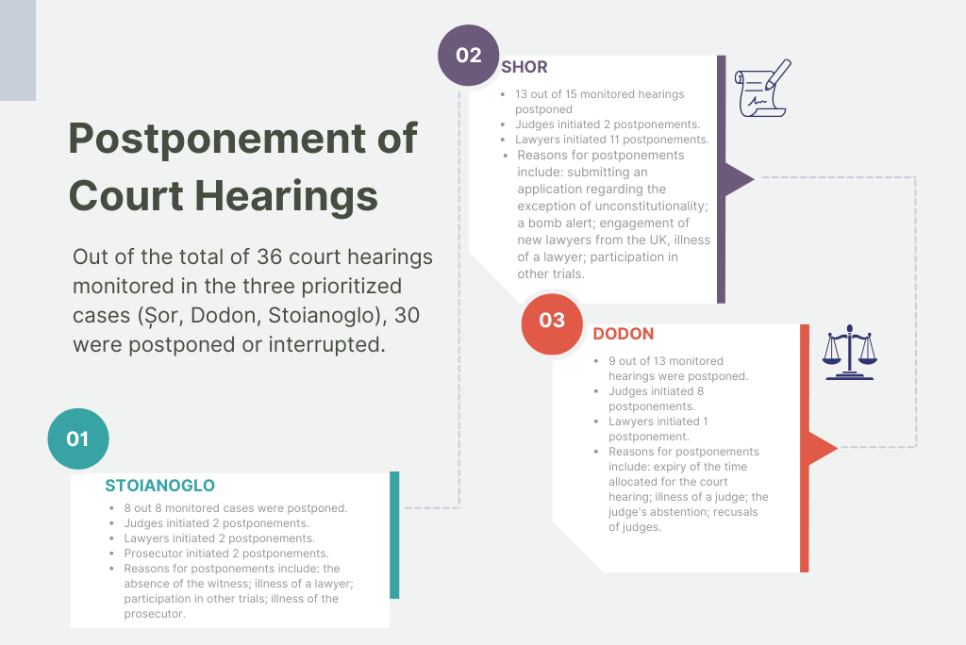

- In a broader context, it was suggested that fear and public opinion play pivotal roles in the realm of high-profile cases, influencing decision-making and raising questions about the quality of judgments and the preservation of judicial independence and impartiality. Public opinion exerts significant influence, with judges feeling pressure to deliver decisions expected by the public or media. Judges often feel vulnerable to societal and media pressures, leading to concerns about public criticism and a lack of support mechanisms.

Upon analysing the monitoring data, several problems inherent to high-profile cases become apparent. Based on this analysis, Recommendations for addressing or mitigating these issues are provided.

Recommendation 1: Enhance the Impartiality and Professionalism of Judicial Proceedings in High-profile Cases. Many first-instance cases are handled by judges with less than 10 years of experience. While this does not question their competence, the intense public scrutiny can potentially affect objectivity. Judges might feel pressured to align with public expectations. Judges with substantial professional experience are generally better equipped to withstand such pressures, having developed the skills and abilities to respond effectively. Consequently, it is recommended:
a) Integrate criteria for determining a case's high-profile nature, including subject matter and public interest, into the random case distribution system.
b) Establish guidelines stipulating that high-profile cases, based on these criteria, should be assigned to judges with over 10 years of judicial service.
Recommendation 2: Ensure Open Court Hearings in High-Profile Cases. Monitoring of court hearings reveals that, in general, the principle of publicity is upheld, although certain deviations from this principle have been documented. These deviations include inaccuracies in the publication of information regarding court hearings and conditional access for monitors, requiring the presentation of identity documents and specifying the purpose of monitoring. Conversely, some cases witnessed a positive reception of monitors by participants who welcomed their presence, emphasizing their role in ensuring adherence to procedural rules.
A notable characteristic of high-profile cases, particularly the Dodon and Shor cases, is the presence of "supporter teams" within the courtroom and in proximity to the courts. While this aligns with the principle of open court hearings and complies with the Law of the Republic of Moldova on Assemblies, certain incidents observed during court hearings, such as the disruption caused by a Member of Parliament during the Shor case, underscore the need for responsive measures.
Therefore, it is recommended to develop and implement internal court-level mechanisms and protocols for prompt responses to such situations, safeguarding the principle of open court hearings without compromise.
Recommendation 3: Improve Court Hearing Coordination. This issue affects all case types, but it's more pronounced in high-profile criminal cases, where delays can be strategic. Monitoring revealed frequent postponements due to coordination issues. To address this, create a unified electronic system for judges, prosecutors, and lawyers to schedule and coordinate hearings, ensuring efficiency and fairness.
Recommendation 4: Promote Legal Stakeholder Collaboration for Efficient Trial Scheduling. Lawyers have frequently delayed high-profile cases, particularly in the Shor case, using various tactics to protect their clients' interests. This repetitive use of similar excuses for postponing trials, like concurrent court hearings or the absence of one defence team member, erodes trust in the criminal justice system and delays proceedings. Courts do not consistently apply sanctions for unjustified delays, and they sometimes postpone hearings due to their scheduling or judge-related issues. This lack of coordination and recurring delays fuels mistrust among participants and the public. To address this, we recommend establishing regular meetings among judicial, prosecutorial, and legal administrative bodies to address organizational and procedural challenges collaboratively, recognizing that justice is a collective effort.
Recommendation 5: Improve Public Communication in the Courts. Monitoring revealed presumptive pressures in high-profile cases. In addition to the challenge of judges feeling tempted to align with public expectations, there is a noticeable lack of effective communication about court proceedings and decisions. To address this issue and alleviate public distrust in the justice system, we recommend enhancing the courts' public communication capabilities by either appointing a professionally trained communicator or a judge within the court responsible for public communication.

7. PROFESSIONALISM OF LAW-RELATED ACTORS

The central idea that brings together all law-related actors is the strong need for consistent professionalism. While judges, prosecutors, and lawyers occupy distinct roles within legal proceedings, their collective commitment to professionalism is fundamental for the effective functioning of the justice system and the protection of human rights. The monitoring offers a comprehensive assessment of the professionalism among the law-related actors reveals both commendable attributes and areas in need of enhancement.
Professionalism of Judges and Judicial Personnel
- Court Users Surveys revealed that satisfaction ratings concerning judges' attitudes and fairness of proceedings varied across case types, with civil cases showing higher approval compared to other types. Overall, the results of the monitoring underscore judges' professionalism, with court users emphasizing the importance of judges' preparation and attentiveness.
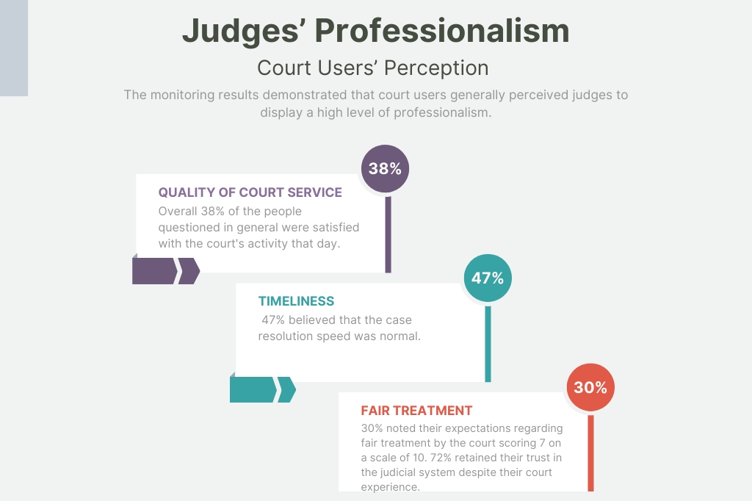
- Issues such as insufficient time allocation for arguments and inconsistency in maintaining quality standards during hearings were noted, in particularly by legal professionals. Dissatisfaction, among other things, is often linked to the coordination in setting hearing times and maintaining punctuality, ability to present their cases before judges, judges' attentiveness to arguments, clarity of court decisions. The feedback from Expert Interviews echoed and expanded upon these findings. Experts underlined challenges in ensuring judicial continuity, the need for better communication and coordination, and the impact of high workload on the quality of court services. Unmotivated judgments highlighted the complexities of ensuring consistent professionalism.
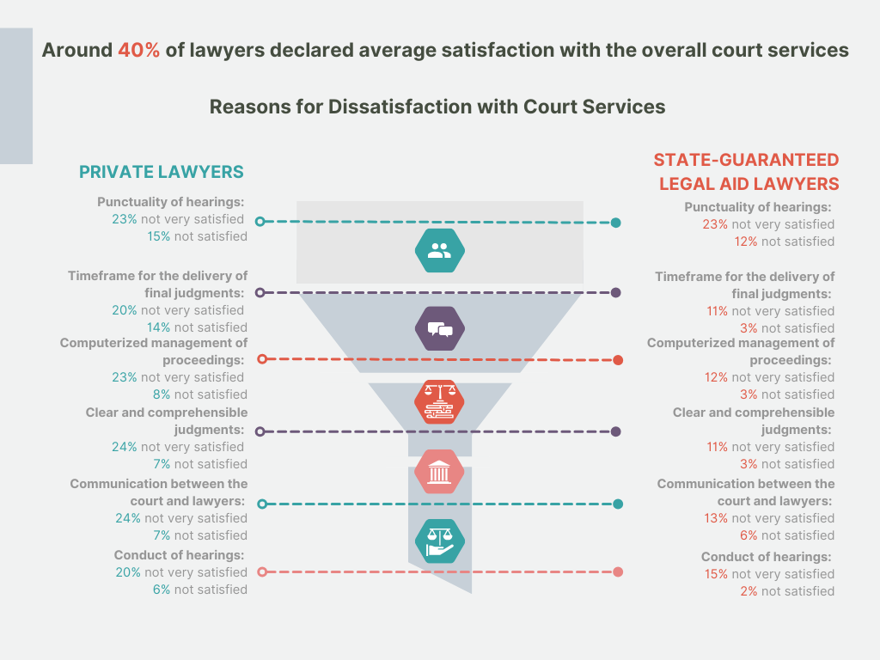
- Key areas for improvement encompass case preparation, attentiveness during proceedings, well-motivated judgments, and effective communication. The following list outlines the issues that need to be addressed:
1. Excessive Case Load: Moldovan judges face a significant challenge with excessive caseloads, leading to delays in proceedings, potential compromises in the quality of decisions, and hindered access to justice for litigants.
2. Duration of Court Hearings: Prevalent court hearings lasting either 15 or 30 minutes raise concerns about the adequacy of time for thorough case examination, argument presentation, and comprehensive deliberation.
3. Punctuality and Scheduling of Court Hearings: The court hearings often face delays and postponements, impacting the overall efficiency and effectiveness of the judicial process.
4. Insufficient Explanation of Procedural Rights: Judges' explanations of participants' procedural rights and obligations are often formal and inadequate. This hampers clarity and understanding, especially for those not professionally represented by lawyers.
"No one ever explains properly. Reading what is written in the code is not an explanation. If they simply provide a signed excerpt from the legal code about rights, it's not an explanation of rights; it should be done completely differently. Very rarely do judges explain the parties' rights understandably (not to lawyers, who already know)." - Expert 18 (lawyer)
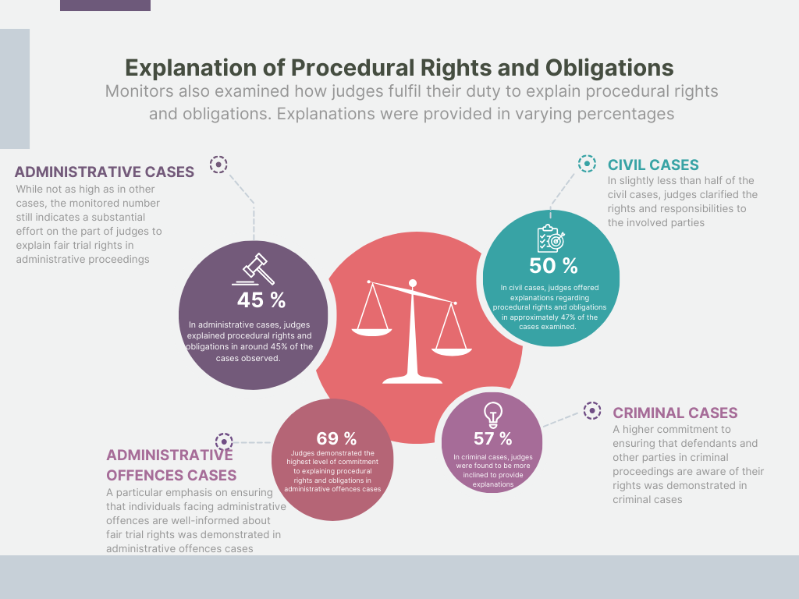
5. Quality of Judgements: The quality of court decisions is inconsistent, with some judgments lacking thorough analysis and proper reasoning. Judges sometimes copy-paste arguments from parties without proper evaluation. The absence of uniform case law and well-developed arguments and explanations in court decisions at the moment of pronouncement has an impact on the perception of fairness.
6. Communication and Coordination Issues: Ineffective communication and coordination between judges, lawyers, and other law-related actors pose challenges in coordinating hearing times, setting priorities, and managing workloads. Resistance to adopting electronic methods in legal proceedings complicates communication and the service of procedural documents.
7. Lack of Preparation and Continuity: Overbooked court hearings result in interruptions, delays, and challenges in maintaining a continuous and coherent judicial process.
8. Lack of Training and Standardization: Inadequate training and standardized practices contribute to the inconsistency of judges' professionalism, organizational skills and courtroom conduct. There is a need for specialized training in managing court proceedings and working time.
9. Shortage of Qualified Personnel: When discussing the professionalism of judicial personnel, it's important to note that, despite the critical role of court staff's competence and professionalism in delivering court services, the Moldovan judicial system faces a shortage of qualified personnel. Low salaries and a heavy workload negatively impact the professionalism of the court and lead to staff shortages.
Professionalism of Lawyers
- Court users express a high level of satisfaction with the legal assistance provided by both state-funded and private lawyers.
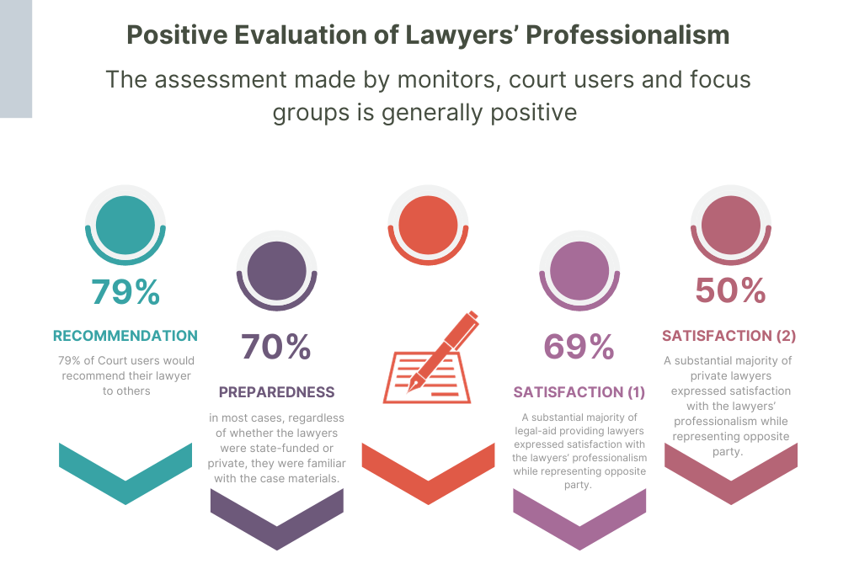
- While certain experts observe advancements in the quality of legal services, others draw attention to concerns like lawyers' lack of preparedness and passive involvement within state-guaranteed legal aid. Additionally, the significant issue of insufficient remuneration and high workload encountered by state-guaranteed legal aid lawyers is emphasized.
- The problem of trial postponements caused by lawyers' absence can be attributed to the lack of a mechanism for judges to determine if the legal representative is occupied with another case.
Professionalism of Prosecutors
- The professionalism of prosecutors is a subject that warrants careful consideration. The results of the monitoring reveal several critical issues that merit attention:
1. Divergent Satisfaction Levels with Prosecutors' Competence: While recognizing the significance of professional competence among prosecutors, there exists a considerable variation in satisfaction levels, particularly among private lawyers and court users.
2. Quality and Role of Prosecutors: Concerns about the quality of prosecutors' work arise from perceptions of inadequate preparation, reliance on templates and limited contribution to proceedings.
3. Procedural Challenges: Reluctance to adopt remote hearings and excessive bureaucratic processes have a detrimental impact on the effectiveness of prosecutors' roles.
4. Inadequate Case Presentation by Multiple Prosecutors: The division of responsibilities among multiple prosecutors in the same case contributes to confusion, inefficiency, and insufficient case presentation.
To ensure that the professionalism in justice system is upheld and enhanced, the following principal recommendations are made:
Professionalism of Judges and Judicial Personnel
Recommendation 1: Enhance Judicial Case Management by implementing a comprehensive strategy to optimize court proceedings. This includes the establishment of strict calendar management practices, incorporating fines for delays and postponements. Using technology, the court system should streamline scheduling, minimize conflicts, and ensure timely and efficient proceedings. Additionally, introduction of an online communication platform to coordinate hearing times among judges, lawyers, and parties, possibly integrated into the electronic case allocation system, could provide valuable data on case participant availability.
Investment in digital tools and platforms for electronic filing, case tracking, and remote hearings is imperative to expedite proceedings and alleviate administrative burdens. Enacting regulations that officially authorize the service of legal documents through electronic means will ensure legal validity and acceptance.
Active case management should be promoted, encouraging judges to proactively set realistic hearing schedules, ensure adequate preparation, and maintain continuity throughout proceedings. Addressing the issue of case overload is vital to prevent judges from rushing through cases and to improve the overall efficiency and quality of the judicial process.
Recommendation 2: Improve Explanation of Procedural Rights. Mandate judges to provide clear and accessible explanations of procedural rights and obligations to all participants, using simplified language to enhance understanding.
Recommendation 3: Strengthen Standards on Judgements’ Quality. Establish guidelines for writing judgments that emphasize thorough analysis, clear reasoning and the incorporation of relevant legal precedents. Encourage judges to provide detailed explanations for their decisions. Establish mechanisms for the development of consistent case law, allowing judges to refer to the precedent and reducing the need to reinvent solutions for similar cases.
Recommendation 4: Enhance Court Personnel Quality and Efficiency. To address the shortage of skilled court staff, it is essential to implement a multifaceted strategy. This strategy should focus on enhancing personnel recruitment and retention by re-evaluating conditions and offering competitive salaries and benefits to attract capable individuals to the judicial system. Additionally, investment in comprehensive training programs for assistants and secretaries, led by the National Institute of Justice, is highly recommended to equip them with the necessary skills to effectively contribute to court proceedings. Workload management measures must be implemented to allow staff to prioritize quality over quantity, alleviating work pressure and ensuring adequate preparation time. Furthermore, investing in technological solutions and automation is essential to streamline administrative tasks, ultimately liberating court staff's time for more substantive contributions to the judicial process. This holistic approach will significantly improve court personnel quality and the efficiency of the judicial system.
Professionalism of Lawyers
Recommendation 1: Enhance Case Preparedness. There is a need to increase the percentage of lawyers’ preparedness for cases hearing. To address the issue of varying levels of lawyer preparedness and enhance the overall quality of legal representation, it is recommended to establish comprehensive and mandatory continuing legal training programs for both private and state-guaranteed lawyers. Moreover, these programs should address the challenges of workload to help mitigate their impact on lawyers' ability to adequately prepare for cases. Collaborative efforts between legal associations, bar associations and judicial institutions can facilitate the implementation and effectiveness of such education initiatives.
Recommendation 2: Establish Uniform Quality Standards for Legal Representation Services. Develop comprehensive guidelines and standards for legal aid services that apply uniformly to both state-funded and private lawyers, ensuring consistency in the quality of representation provided to litigants. This can involve standardized training, ongoing professional development and regular assessments of lawyers' performance to maintain a certain level of competence and preparedness.
Recommendation 3: Streamline Trial Scheduling and Adjournments. Introduce a scheduling mechanism that allows judges to assess lawyers' availability and workload before assigning trial dates, minimizing trial postponements caused by lawyers' absence and optimizing judicial resources.
Recommendation 4: Enhance Trust and Collaboration Among Legal Actors. Establish regular communication channels and collaborative platforms among judges, lawyers, and court staff to foster better understanding, cooperation and mutual respect, thereby improving trust levels between the law-related actors.
Professionalism of Prosecutors
Recommendation 1: Enhance Prosecutor Training. Implement comprehensive training programs aimed at enhancing prosecutors' competence and procedural skills. Address concerns raised by legal professionals regarding the quality of procedural documents prepared by prosecutors.
Recommendation 2: Streamline Procedures. Undertake a thorough review of procedural rules to simplify and reduce bureaucratic processes. This effort will minimize opportunities for corruption and contribute to the overall efficiency of the criminal justice system.
Recommendation 3: Embrace Remote Hearings. Advocate for the adoption of remote hearing options among prosecutors. This approach minimizes delays, optimizes resource utilization, and improves overall efficiency.
Recommendation 4: Promote Single Prosecutor's Responsibility. Consider introducing a system where a single prosecutor assumes responsibility for managing and presenting a case throughout the entire legal process, from the initial investigation to the trial stage. This strategy ensures continuity, accountability, and a comprehensive understanding of all case details.
Recommendation 4: Sustainable Reform Directions. Given that various experts have highlighted concerns about accusatory bias of criminal proceedings in Moldova and courts’ overload resulting from cases that could be categorized as administrative offenses, it is crucial to take these matters into account when considering broader reforms aimed at enhancing the efficiency of the judicial system, for example by decriminalization of drunk driving. Additionally, the matter of the high number of prosecutors should be further examined to efficiently address the high ratio of prosecutors to the population.

8. CONFIDENCE IN JUDICIAL SYSTEM
The shared responsibility among actors in the justice system is a crucial requirement for creating a more effective judicial system.
The cornerstone of a just and effective legal system is the trust that society places in its ability to uphold the principles of fairness, transparency, and accountability. Confidence in the justice system ensures that individuals perceive their rights as protected and that disputes are resolved impartially. The Trial Monitoring data portrays a positive picture across civil, administrative, criminal, and administrative offences cases, promoting confidence among citizens in the integrity of the legal system. The monitoring assessed several crucial aspects of court proceedings, demonstrating the following key findings:
Openness of Court Proceedings
- Across civil, administrative, criminal, and administrative offences cases, a commitment to transparency was evident, with the majority of court hearings open to the public. While some instances required explanations or identity verification for public access, these measures aimed at maintaining order and safeguarding the court process.
- There were no significant barriers to public access during the monitored cases. Notably, only in a very small fraction of monitored cases the courtroom was closed to the public, there were no responses indicating denial of access due to reasons such as the courtroom being too small, the hearing taking place in the judge's office or similar.
Equal and Efficient Access
- Monitoring offered consistent information demonstrating that the integrity of the observed proceedings was maintained. Judges refrained from revealing their position on case outcomes, reinforcing the perception of impartial decision-making. There were no discussions between court users and judges before or after hearings, emphasizing a professional and unbiased approach. Very minimal inappropriate contacts were noticed among participants to the proceedings, indicating a level of adherence to ethical standards.
- Participants demonstrated satisfaction and confidence with the composition of courts, as challenges to the court's composition were infrequent.
Court Users' Perception of Fairness of the Court Proceedings
- The public's confidence in Moldova's justice system is notably low, as indicated by the Barometer of Public Opinion (November, 2022) and the Public Opinion Survey (October–November, 2022). Only 18% of the public expressed confidence in the justice system. While 25% had a positive opinion about the courts, a majority of 56% held a negative opinion. To delve deeper into the level of trust within the justice system, the Trial Monitoring focused on the experiences of actual court users, shedding light on the trust based on personal experiences and despite positive interactions among court users, the public's negative perception of the justice system remains a challenge.
- The results highlight a stable positive level of satisfaction among court users. A majority of court users (a combined total of 62% of respondents) expressed satisfaction with the court's services. Larger levels of dissatisfaction with the court services were documented regarding criminal cases and administrative offences cases.
- Expectations of fair treatment before coming to court varied among respondents, with the majority expressing moderate to high levels of trust. The majority of court users reported that their trust in the judicial system remained unchanged after their court experience. A small percentage (16 %) saw an increase in trust. A minor fraction of court users (12%) expressed that their trust in the judicial system decreased.
Judicial Independence
"The pressure from society and journalists is intense, and it's the most concerning. We don't feel like anyone will protect us, neither the Judicial Council nor anyone else because they've painted such a negative image of us that even if someone tries to defend us, they'll automatically be seen in a negative light." - Expert 19 (judge).
- Judicial independence and the separation of powers are fundamental building blocks of a democratic society. They guarantee that judges are free to exercise their judicial powers without interference from litigants, the state or the media. The observed trends point at the importance and significant shortcomings concerning judicial independence.
- The monitoring results warn against the risks of weakening the already fragile protection of judicial independence. A minority of private lawyers (13%) believe that judges have not been subject to undue influence, compared to state-guaranteed legal aid lawyers (31%). A large part of respondents (49% of private lawyers) believe that an equal distance is not maintained from the parties to the proceedings and their respective interests in the case. Further, the findings suggest the possible influence of politicians which stresses the need to observe checks and balances in the administration of the judiciary and alerts to the fact of its politicization. In addition to this, almost one third of respondents consider that inappropriate pressure or interference is exerted by the media.
- Several internal concerns were articulated, including the impact of inadequate remuneration and the resulting recruitment and retention challenges. Moreover, the absence of comprehensive training, the lack of solidarity among judges, and the subsequent erosion of authority within the profession emerged as significant concerns.
- Despite the reservations legal professionals may have regarding potential interference with judicial powers, the professionalism of judges, prosecutors, and lawyers is generally viewed positively. Expectations concerning the independence of the justice system are not excessively high; they are rather realistic. Legal professionals recognize the legal environment and the possibility of situations that could compromise independence. Interestingly, this factor does not appear to impact their perception of judges' professionalism, as no correlations between these two indicators were observed. This level of acceptance demonstrated by legal professionals is particularly concerning and could potentially undermine overall trust in the judicial system.
- A consensus emerged that upholding respect of the judicial role across all state powers and media is the primary avenue for reinstating the confidence in justice system. Increasing the predictability in the system could further strengthen the trust and address the deep-rooted suspicion inherent within the system itself. Rebuilding trust requires addressing these barriers and fostering a more positive perception of the judiciary's role.
Accountability
"The profession of a judge means to listen, form an opinion, and explain how you arrived at it." - Expert 12 (lawyer).
- Within the surveyed group of judges and judicial staff, 65% concurred that the implementation of Quality Standards for Judicial Decisions could contribute to enhancing trust in the justice system. However, it is evident that while the impact of Quality Standards for Judicial Decisions on rebuilding trust is acknowledged, it is considered to be just one facet of a broader effort to restore public confidence in the judicial system.
- Non-mandatory reasoning of court decisions contributes to legal uncertainty. The current approach fails to alleviate high caseloads or provide clear guidance to participants. However, legal professionals expressed varying opinions on the matter. Some argued that the current practice need not be changed, citing reasons like heavy workloads, appeal rates, and the flexibility for participants to request reasoning. Nonetheless, there was consensus that a detailed evaluation of the practice is necessary, particularly for specific types of cases. While legal professionals generally believed the existing practice is workable, there was an acknowledgment that the possibility of change should be explored.
To ensure that the confidence in justice system is upheld and enhanced, the following principal recommendations are made:
Transparency
Recommendation 1: Strengthen the Public Engagement. Moldova has made significant progress concerning public access to court proceedings, the minimal occurrence of inappropriate contacts, and judges' consistent neutrality all contribute to building and sustaining public trust in the judiciary. On this basis, continuous efforts should be made to sustain and further enhance accessibility and ensure that all members of the public can observe and engage with the justice system effectively. There is scope for enhancement through the establishment of feedback mechanisms for court users and the implementation of regular monitoring and assessments of transparency measures, including the release of periodic transparency reports.
Public Trust
Recommendation 1: Address the Challenge of Public Distrust in the Justice System. Despite positive interactions among court users, the public's negative perception of the justice system remains a challenge. Efforts to enhance transparency, efficiency, and accessibility within the justice system should continue in order to rebuild public trust and to align it with positive or neutral experiences of actual court users. Notably, step up efforts should be made to create more active public education campaigns to inform the public about court processes and the role of the judge; to ensure public consultations when considering reforms or changes to the justice system; to ensure the judiciary is providing clear explanations for judicial decisions and making court documents readily available for the public. Ultimately, nurturing a more positive perception of judiciary's role within society, with engagement of various government actors, including politicians, is paramount to restoring public confidence and upholding the principles of justice.
Independence
Recommendation 1: Take Comprehensive Measures to Ensure Adequate Safeguards against Undue Political Influence in the Administration of Justice, in alignment with European standards on judicial independence and impartiality.
Recommendation 2: Improve Contacts between Courts and the Media in order to Enhance Mutual Understanding of their Respective Roles. Avenues should be explored to improve contacts between courts and the media: to strengthen understanding of their respective roles; to inform the public of the nature, the scope, the limitations and the complexities of judicial work; each profession (judges and journalists) should draw up a code of practice on its relations with representatives of the other profession and on the reporting of court cases.
Recommendation 3: Self-regulatory Judicial Bodies must Prioritize the Protection of Judges. Given the prominent place of the judiciary within the system of the separation of powers and the emphasis placed upon judicial independence and impartiality, the self-regulatory bodies (council for the judiciary or judges' associations) must pay particular attention to the protection of judges when a judge or a court is challenged or attacked by the media or by political or other social actors by way of the media for reasons connected with the administration of justice.
Recommendation 4: Prioritize the Allocation of Adequate Human and Financial Resources for the Courts. In light of the observed challenges, the path to rebuilding trust should follow a holistic approach. Effectively addressing barriers requires efforts to provide adequate human and financial resources for the functioning of the courts, taking into account European standards on judicial resources. In particular, concerns regarding the adequacy of the resources allocated to court staff, such as judicial assistants and court hearing clerks, should be addressed.
Accountability
Recommendation 1: Further Continuous Efforts should be made to Strengthen the integrity Framework. Having regard to the fact that the perception among legal professionals is that the level of corruption in the justice system remains relatively high, the effects of the anti-corruption agenda and laws on corruption prevention should remain to be continuously assessed. In addition to this, regular ethics and accountability training for judges, lawyers, and court personnel to emphasize the importance of integrity, impartiality, and fair conduct should be provided.
Recommendation 2: Promote Quality Standards for Court Decisions. Increasing the quality of reasoning for court decisions is essential for promoting transparency, accountability, and public trust. Implementation of quality standards should be followed by regular professional development events (seminars, conferences, workshops) that focus on enhancing legal reasoning skills and effective judgment writing. Judges should be allowed to work closely with skilled legal assistants who can help with thorough legal research, drafting, and structuring of judgments.
Recommendation 3: Re-evaluate the Practice of Non-Mandatory Reasoning in Respective Categories of Cases to Increase Trust within the Judicial System itself. In the pursuit of restoring public confidence, it is paramount to not only mend external perceptions but also to foster trust and credibility within the justice system itself. To achieve this, steps to address the legal uncertainty that legal professionals may have regarding the reasons behind adopting specific court decisions should be taken. Concurrently, avenues should be explored to increase legal certainty and predictable judicial process. As part of this effort, categories of cases wherein the reasoning for court decisions should be consistently provided should be reconsidered.

9. QUALITY OF JUDICIAL DECISIONS

The Monitoring of Judicial Decisions contain structured information for assessing the quality of court decisions. This information was collected during the monitoring of 400 court decisions issued by the courts of the Republic of Moldova between 2020 and 2022. The majority of analysed court decisions (72% or 287) were issued at the first instance, while 15% (60) were on appeal, and 13% (53) were on cassation. The monitoring considered key criteria of court decisions related to legality, persuasiveness, transparency, linguistic correctness, clarity, and structure.
Legality
- Legal compliance is considered an essential attribute of a quality judgment, with 88% agreement among judges and 93% among assistant judges.
- A significant percentage of court judgments across different instances do not refer to the previous case-law, which is crucial for ensuring uniform judicial practice and legal clarity.
- The findings highlighted the complexity in the use of general principles of law in court decisions. At the first instance, only 11% of cases relied directly on general principles of law. In contrast, the appeal instance predominantly refrained from direct invocation, with 75% of cases not drawing from these principles. 68% of cassation cases did not directly refer to general principles, but 23% explicitly incorporated them with content clarification.
Persuasiveness
- In one-third of cases, the court specified reasons for rejecting certain evidence, with variations across different instances.
- Fewer decisions provide assessments of the losing party's arguments, with this aspect particularly lacking at the cassation level.
Transparency, Consistency and Sufficiency of Reasons
- Clarity of reasons is recognized as a fundamental aspect of court decisions, with 83% of judges and 85% of assistant judges acknowledging its importance.
- While most cases clearly answer key factual questions, there is room for improvement in presenting established facts in chronological order and distinguishing them from evidence or participant versions.
- A more comprehensive examination of alternative options is more common in cassation cases, with a focus on both "for" and "against" aspects.
Linguistic Correctness
- The text of court decisions lacks a unified standard, and font and language use vary.
- Most decisions are written in an easily understandable language without linguistic errors, but specific terminology is often not explained. Latin terms, prevalent in cassation decisions, are used without clarification.
Clarity
- In half or fewer cases, court arguments and reasons are clearly distinguished from party explanations and evidence.
- The operative part of the decision is clear in explaining how it should be executed.
- First-instance decisions generally specify the term and procedure for filing appeals, while this clarity in appeals varies.
Structure and Form
- Most court decisions in Moldova do not include page numbers. A significant majority distinguishes structural parts required by law, but this aspect can be improved, especially at the cassation level. Descriptive and reasoning parts are often not numbered in court decisions.
Increasing Trust and Quality of Court Decisions
"Well-structured and reasoned judgments can increase society's confidence in justice" - Comment from Focus Group Surveys
- While a majority supported the introduction of approved quality standards for court decisions, effective implementation and continued training are key to realizing these improvements and ensuring the independence of judges.
- The majority believed that quality standards should be issued as recommendations by the Supreme Court of Moldova, granting them legal significance.
- Respondents also suggested that special training on quality standards, as well as argumentation theories and methodologies, should be provided to judges and their assistants (79%). Awareness-raising measures, including discussions, consultations, and sharing best practices, were also favoured (52%) to promote compliance with these standards.
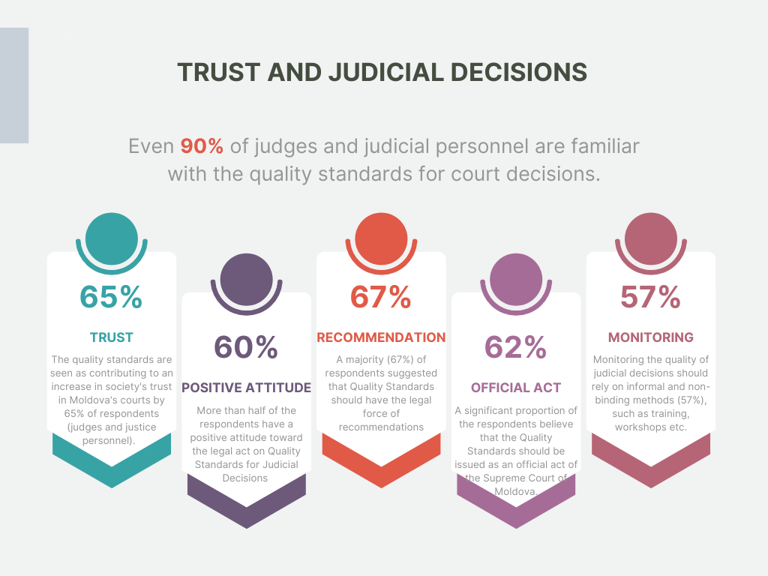
Respect of Principle of Legal Certainty
- The monitoring reveals that disparities in the interpretation and application of the law across different courts can undermine the fundamental principle of legal certainty. Even though some procedural codes might not explicitly cite deviations from uniformity as grounds for cancelling decisions, maintaining such uniformity remains crucial in ensuring respect for the rule of law.
- The Monitoring of Judicial Decisions demonstrates that judges in Moldova typically do not refer to the practices of other courts in their decisions. However, Expert Interviews indicated a clear interest in how the law is applied and interpreted in other courts. This interest allows judges to compare their reasoning with that of their peers in previously decided cases, ensuring consistency with prevailing trends.
- The challenge arises from the fact that procedural legislation exhaustively outlines the structure of a court decision and provides a closed list of what can be included, such as in the reasoning part of the court decision. All other information, including references to other judicial acts or the practice of applying and interpreting the law, should not be included in the motivational part.
- On one hand, supreme courts have the authority to issue guiding explanations regarding the interpretation of legal rules, which lower courts must adhere to. On the other hand, lower courts, due to the stipulated provisions in procedural codes, cannot include references to these guiding clarifications and other interpretative acts of the supreme courts in their reasoning. This concept that "a judge is bound only by the law" conflicts with the everyday practice of judges who often seek to align their decisions with the practices of higher courts and avoid deviating from established judicial norms.

Overall, the positive impact of quality criteria for judicial decisions as a means of increasing society's trust in Moldova's courts and safeguarding the quality of the justice system is widely recognized. To achieve these goals, it is essential to identify the main objectives and provide specific recommendations for their implementation.

Recommendation 1: Ensure the adoption of fair and lawful court procedural decisions, thereby enhancing public confidence in Moldova's court system.
1. Consider the adoption of the Quality Standards for Judicial Decisions as a legal guideline. These standards should carry the force of recommendations, setting forth minimum requirements for argumentation methodology and the model structure of court decisions.
2. Establish an ad hoc working group within the Superior Council of Magistracy, the Agency for Courts Administration, or the Supreme Court to unify various quality practices for court decisions across different courts and cases, resulting in final court decisions.
3. Introduce the Quality Standards provisions that outline specific requirements applicable to different judicial instances, including appellate and cassation levels.
4. Include a provision in the Quality Standards for Judicial Decisions requiring the numbering and structuring of paragraphs within court decisions.
5. With regard to ensuring the quality of judicial decisions, it can be assumed that amending relevant legislative provisions in the Code of Criminal Procedure, Code of Civil Procedure, Administrative Code, and Code od Administrative Offenses to allow references to guiding clarifications and other interpretative acts of the Supreme Court in the reasoning part of court decisions would help enhance the quality of judicial acts and legal proceedings in general.

Recommendation 2: Ensure the effective application of Quality Standards for Court Decisions in all categories of cases and to encourage judges and judge assistants to rely on them when preparing final court procedural decisions.
1. Ensure that appointed judges, appointed assistant judges, and currently working judges and assistant judges effectively apply the Quality Standards for Judicial Decisions. Provide already working judges and assistant judges with knowledge of "best practices" for applying the Quality Standards for Judicial Decisions across different case categories.
2. Develop and approve a mandatory introductory training program for judges, titled "Trust in the Judicial System and Quality Standards of Court Decisions".
3. Integrate specialized courses into the ongoing training for judges and judge assistants, covering quality standards and reasoning in different case categories: criminal, civil, administrative, and administrative offenses.
4. Include refresher courses on computer literacy in the training programs for judges and judge assistants.

Recommendation 3: Raise awareness of the Quality Standards for Judicial Decisions in Moldovan society and encourage the professional legal community to participate in processes aimed at improving the quality of court decisions.
1. Initiate and hold public debates or discussions involving representatives of the judicial system, the prosecutor's office, the bar association, and the legal academic community to address relevant issues related to the quality of court decisions.
2. Launch a pilot project to monitor the quality of court decisions within a specific district court's jurisdiction. This project should involve all courts operating in that district and include participation from various institutions, such as lawyers, prosecutors, and police officers involved in pre-trial investigations. Develop a detailed plan for quality development and its step-by-step implementation within the district court's jurisdiction. Create a joint committee responsible for supervising the implementation of the quality project, with representatives from all state institutions interested in improving the quality of justice.

Recommendation 4: Establish a comprehensive quality management system for the judicial system in Moldova, integrating methodological support for the application of Quality Standards for Judicial Decisions and a monitoring system for their application.
1. Appoint an individual for each court district who will consistently provide methodological support and consultations to judges and assistant judges on relevant issues arising in their daily work regarding the application of Quality Standards for Judicial Decisions.
2. Periodically review the practice of applying Quality Standards for Judicial Decisions in each court, based on one or more specific criteria outlined in these standards.
3. Conduct an expert qualitative analysis and monitoring of the quality of all court decisions in Moldova's court system every 3–5 years. This analysis should be based on an examination of specific court decisions to assess compliance with the quality standards.
4. Conduct regular quantitative and qualitative surveys of judges, assistant judges, and other court employees regarding various aspects of the application of Quality Standards for Judicial Decisions.
5. If there is a consensus among the community of judges within a court, consider implementing peer reviews of court decisions in which judges review and assess each other's adherence to Quality Standards for Judicial Decisions.
6. Monitor the quality of judicial decisions through informal and non-binding methods, such as conferences, discussions, workshops, the sharing of best practices, and examples.

Ilan Shor is accused of large-scale fraud and money laundering during his tenure as Chairman of the Board of Directors of BEM. According to the indictment, Shor is alleged to have obtained more than $5 billion through fraudulent means.
Igor Dodon is accused of receiving between $600,000 and $1 million in bribes from Plahotniuc and allowing the "Plahotniuc criminal organization" to finance the Party of Socialists, as seen in the "Kuliok" case.
The suspended Prosecutor General, Alexandr Stoianoglo, is accused of committing the crime outlined in Article 328(3)(b) of the Criminal Code, which pertains to exceeding official duties. Alexandr Stoianoglo and his former subordinate are accused of ordering the payment of severance pay to the prosecutor N.C., despite being aware that a criminal investigation was ongoing concerning N.C. According to legal provisions, in such cases, the payment of severance pay to resigning prosecutors is suspended.

